eFONA registry data set

Section 1 Free Text Summary
Please provide a brief summary of the case (approximately 200 words, although up to 500 (insert limit of text box) can be used. Common abbreviations and bullet points are acceptable. Please do not be concerned about style conventions or grammar. It is your recollection of the important points relating to the most valuable case.

Section 2: Patient

2.1 Sex assigned at birth
2.2 Ethnicity The ethnic groups are based on the UK Census 2011 categories.
2.3 Age (years, nearest estimate if unknown)
2.4 ASA physical status classification
2.5 BMI
- Enter weight and height if available (BMI will be calculated for you), or use the categories below
2.6 Pregnancy (offer if female AND <60 years)
Was the patient known to be pregnant?

Section 3: Setting & Timings
3.1 Where did the eFONA event occur?
3.3 Was airway management part of –
[tick box options to choose - any/all]
- Primary Airway Problem
- Facilitation of a different procedure/surgery
- Cardiac arrest resuscitation

3.3a If yes please specify main surgical speciality
3.3b Please specify clinical urgency of case
3.4 For events that occurred on a critical care unit – only if selected in 3.2
For the eFONA event on Critical Care - was the patient a new admission?
3.6 For events in ED – only if select in 3.2
What was the primary reason for airway intervention?
For ED/ICU/theatres
3.6.1 Did the patient arrive with an airway device in place?
Cardiorespiratory Arrest
At what point in the airway management did cardiorespiratory arrest occur?
Options to tick - Prior to any airway intervention, or Post intervention, If post then free text box for estimate of time in minutes or number of airway interventions or CICO
Was cardiorespiratory resusitation successful?
Duration (approximately) from start of airway management until death
(within ? Days or discharge) Only if a death option selected
3.7 When did this episode of airway management start
3.7.1 Was this a
- Weekend
- Weekday
- Public holiday

Timing of events (enter an estimate in minutes of best estimate/approximate as able to recall)
Please now use the 24 hour clock for the approximate time (or duration) of the following events. (don’t know is always an answer, but estimates are useful)
3.8.1 Duration from the time of induction/airway management to failure of first airway manoeuvre
3.8.2 Time spent on rescue oxygenation attempts (excluding eFONA) using either a supraglottic device or face-mask oxygenation or airway adjunctions/manoeuvres
3.8.3 After how many minutes did critical hypoxia (SpO2 < 80%) occur?
3.8.4 Call for eFONA kit
3.8.5 Start of eFONA attempt
Duration of airway management before eFONA attempted
3.8.6 Airway secure and confirmed using capnography?

Section 4: Preparation
4.1a Before the procedure did the patient have clinical evidence of airway obstruction (including but not limited to stridor, obvious swelling, voice changes, airway surgery, burns, etc)
4.1b Was this primarily due to a depressed level of consciousness?
4.2a Did the patient have any of the following signs or symptoms
[tick any/all that apply] no evidence of airway obstruction (if tick this then rest disappear) stridor/dysphonia/drooling/progression to silent airway/free text optional
4.3 Was there a history of difficult airway management on a previous occasion
4.3a If YES, was the principal airway manager aware of this before undertaking this episode of airway management?
4.3b – only if yes then -- > What was the difficulty previously experienced?
4.4 What predictors of difficult airway management were identified during the airway assessment? (clinical impression, bedside test, or formal investigation)
Yes No Impossible to conduct any sort of assessment (this will skip all questions on detail)
Give them tick boxes for the following tests, if they select it then it would give them further options to select
4.5 Modified Mallampati
  - Mouth opening (interdental distance – teeth or gums) – in this case only 1 option to tick, not mandatory
4.7 Neck Movement
  - Jaw protrusion
  - Upper lip bite test
  - Thyromental distance
** additional tick boxes
Large tongue
Obstructive Sleep Apneoa
Obstruction (e.g. epiglottitis, peritonsillar abscess)
Obesity
Hypoxemia (Sp)2 <80%)
Non-anaesthetist airway manager
  - Was a Cricothyroid Membrane assessment performed?
  - Were any other further tests performed or reviewed?
  - Did the findings of the assessment predict
4.15a Difficult preoxygenation
4.15b Difficult face mask ventilation
4.15c Difficult supraglottic airway insertion
4.15d Difficult direct laryngoscopy
4.15e Difficult videolaryngoscopy
4.15f Difficult Front of Neck Airway
4.15g Difficult awake tracheal intubation (ATI)
4.15h High risk extubation
4.16 Did the assessment predict that the patient was at increased risk of aspiration?
  - Did the assessment reveal any other predictors of difficulty not otherwise recorded , identified at pre-op assessment (or at assessment prior to the induction of anaesthesia)
    - If any yes – Was the airway management plan designed to cope with these difficulties or was it modified to take account of them?
  - Were there any additional predictors of difficult tracheal intubation identified in hindsight

Section 5: Personnel
The first questions in this section relate to the clinician initially leading/ planning airway management- The planner- this may be separate from the clinician actually doing the airway management- see below
5.1 Information regarding the clinician initially leading airway management (i.e. the one making the decisions and deciding the primary plan) –

5.1a Primary specialty
5.1c Have they had any form of planned hands-on airway teaching?
(i.e. attended or been a trainer on a specific local, regional or national workshop based training event in the previous 2 years)
5.2 Was a back-up airway planner/ leader considered?
5.3a Primary specialty of back-up airway planner
5.3b Grade of back-up airway planner/leader
5.4 Was there a trained assistant present to assist with airway management?
if yes move to 5.4a. if no move to 5.5
5.4a If YES, ask - What was their normal role?
5.4b Had this person had any form of planned airway teaching (local, regional or national event in the past 2 years)?
5.6 This question does not relate to the performance of eFONA. The airway manager refers to the person actually managing the airway and may be different from the person responsible for the airway plan above and may include personnel from other staff groups)
How many airway operators did the airway plan involve?
5.6a Grade of Airway primary airway manager
5.6a How many attempts at managing the airway did the primary airway manager have?
5.6b Grade of airway manager 2
5.6b1 How many attempts at managing the airway did this airway manager have?
5.6c Grade of airway manager 3
How many attempts at managing the airway did this airway manager have
5.7 Was there a trained assistant for airway manager (ODP/ODA/ anaesthetic nurse etc) present throughout the event?
5.10 Were the following immediately available (without any delay)

Section 6: Checklists and Human Factors

6.1Was a checklist specifically for airway management used?
6.4Was there a ‘team brief’ of any sort
6.4a Was airway management identified as a potential issue at the team brief?
6.5 Was an airway plan/strategy explained to the airway assistant?
6.6 Was an airway plan strategy explained to the team?
6.7 Was all requested equipment available?
6.8 Was an airway guideline explicitly followed or used?
6.9a How was the algorithm used?
6.10 Was a cognitive aid used to facilitate the delivery of an airway guideline but is not the guideline itself e.g. airway trolley stickers, ATI cognitive aid, etc.
Which of these were declared aloud to the whole team? (At this stage the exact form of words are not important but the message intended.)
  - Primary Airway plan (only) discussed with team
  - Intended airway strategy (plans) including actions if each step failed
  - Failed tracheal intubation (at time of failure)
  - Failed facemask ventilation
  - Failed supraglottic airway device placement
  - Cannot Intubate Cannot Oxygenate
If YES to CICO declared, what specific term was used?
If YES, in your opinion, was the declaration of CICO understood by those present?
  - Immediate need for eFONA
If YES, Can you recall the specific term used first to declare the need for an emergency front of neck airway
If YES, was this eFONA declaration understood by all present
  - Cardiorespiratory arrest
  - If Cannot Intubate Cannot Oxygenate situation was declared, what specific term was used?
6.20 In your opinion, was the declaration of Cannot intubate Cannot oxygenate understood by those present?
6.21 If a need for emergency front of neck airway was declared can you recall what specific term was used first?
6.22 Was it understood by those present?
6.23 When help arrived did the individual/team (can pick multiple from below)
The following questions ask you about the team- some are factual and some require your opinion-
6.24 In your opinion what aspects of the teamwork were particular good or bad?
- Consider communication between team members, allocation of roles, effective use of personnel resources, effective use of equipment resources, 'Helicopter view' vs tunnel-vision, etc. when answering this
6.25 Was one member of the team asked to note timings/ scribe?
6.26 Was the identity of the airway leader clear at all times
(even if the leader may have changed during the process)
6.26.1 Were their instructions clear at all time
6.27 Did you have a debrief?
6.28a.Has this event been discussed at an M&M?
6.28b if the patient died was it reported to the Coroner/ Procurator Fiscal?
6.29 Were there any additional patient factors that we have not asked about which may have had an impact on this case?
6.30 Were there any additional equipment factors which we have not asked about which may have had an impact on this case?
6.31 Were there any additional factors affecting individual healthcare personnel which may have had an impact on this case (e.g. fatigue, stress, hunger, illness, emotional)?
6.32 In terms of non-technical skills, were there any particularly good or bad aspects relating to:
- Situation awareness
- Decision making
- Task management
- Teamworking
6.33 Were there any additional environmental factors which may have had an impact on this case (e.g. unfamiliar environment, unfamiliar team, temperature, remote site, PPE that have not already been recorded)?
6.34 Were there any organisational factors which may have had an impact on this case (e.g. lack of safety culture, poor M&M attendance, lack of investment in infrastructure/equipment, newly appointed personnel
6.35 The Yorkshire Contributory Factors Framework is a tool which has an evidence base for optimising learning and addressing causes of patient safety incidents by helping clinicians identify contributory factors.

This diagram depicts the various layers of this framework.

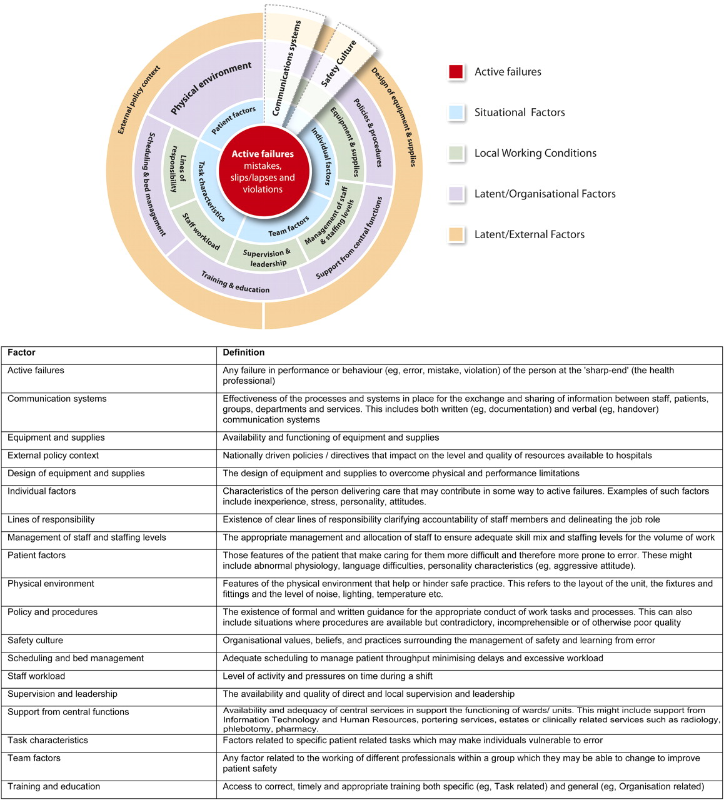

Please consider the following domains, and if any are applicable, please elaborate further in the free text box. We encourage a narrative to help understand the chain of events and contributing factors.

- Situational factors
- Was there any failure of the team function?
For example:
- Conflicting team goals
- Lack of respect for colleagues
- Poor delegation
- Absence of feedback
- Were there any reasons this incident was more likely to occur with the particular staff involved?
For example:
- Fatigue
- Stress
- Rushed
- Distraction
- Inexperience
- Did the task features make the incident more likely?
For example:
- Unfamiliarly with performing eFONA
- Difficulty with deciding to perform or performing eFONA
- Were there any reasons this incident was more likely to occur to this particular patient?
For example:
- Known difficult airway
- Airway obstruction
- Previous radiotherapy to neck
- Previous head/neck surgery

- Local Working Conditions
- Was there a mismatch between workload and staff provision around the time of the incident?
For example:
- high workload
- Insufficient staff
- Staff sickness
- Was there any failure of the team function?
For example:
- Inappropriate delegation
- Unclear responsibilities / accountability
- Inappropriate supervision or support
- Were there difficulties obtaining the correct drugs and/or working equipment and/or supplies?
For example:
- Unavailable drugs
- Equipment not working
- Inadequate availability of equipment

- Organisational factors
- Did the environment hinder your work in any way?
For example:
- Poor layout/ergonomics
- Lack of space
- Excessive noise/heat/cold
- Poor lighting
- Poor access to patient
- Were there any problems with other departments?
For example:
This includes support from
- Porters (e.g. lack of availability leading to delays with transferring patient)
- clinical services such as medical or surgical sub-specialities, theatres (e.g. lack of ENT surgeon availability or theatre availability)
- IT (lack of/ poor access)
- Did any time or bed pressures play a role in the incident?
For example:
- Delay in the provision of care e.g. critical care bed/ ward bed with airway trained staff
- Transfer to an appropriate ward
- Lack of out of hours support
- Were there any issues with staff skill or knowledge?
For example:
- Inadequate FONA training
- No protected time for teaching
- Training not standardised
- No regular/yearly updates
- Poor skills mix

- External factors

- Was there any characteristic about the equipment, disposables or drugs that was unhelpful?
- Confusing equipment design
- Equipment not fit for purpose
- Similar drug names
- Ambiguous labelling and packaging
- Have any national policies influenced this incident?
- Checklists or Algorithm e.g. DAS Unanticipated Difficult Airway

- Communication and Culture
- Did the lack of safety culture contribute to this incident?
For example:
- Patient safety awareness
- Fear of documenting errors
- Attitude to risk management
- Did poor written or verbal communication worsen the situation?
For example:
- Poor communication between staff
- Handover problems
- Lack of communication/notes
- Unable to read notes
- Inappropriate abbreviations used
- Unable to contact appropriate staff
- Notes availability

Section 7: Plan

7.1 What was the primary intended anaesthetic plan?
7.1a which best describes planned induction
7.1b if general anaesthetic planned: did you plan to give a muscle relaxant at induction?
7.1e If general anaesthetic or sedation planned
Was the patient ramped prior to induction
7.1f If General Anaesthesia planned: What was the planned level of consciousness for airway management?
Please select the primary intended airway plan?
7.2 Was it considered carried out?
7.3 Was this a ‘high-risk GA carried out after failed ATI
7.3.1 How many attempts at ATI had there been before GA
7.3.2 Regarding the ATi performer, was use of this technique in their usual scope of work?
7.4a Was the primary plan tracheal intubation?
7.4c What was the planned technique to facilitate tracheal intubation
If no to tracheal intubation in 7.4 c What was the planned primary airway?
7.4k Has your primary airway management plan now been recorded, if not please record it now

Section 8: Pre-Oxygenation and oxygenation between attempts
8.1 Was the patient Pre-oxygenated (or already receiving supplemental oxygen) before induction
8.1a Only if 8.1 yes: Method used (pick the single type one that best describes)
8.1b Again only if 8.1 yes: What pre-oxygenation endpoint was intended
8.1c Again only if yes Did you achieve pre-oxygenation to your satisfaction?
8.1c1 If No in 8.1c If Not, Why?
8.2 Were attempts made to provide supplemental oxygenation after induction and between airway interventions?
8.3 Please select any/all applicable monitoring used?

Section 9: Process

9.1 What was the sequence of Airway management
Mark Help Summoned/ paralysed/ aspiration as separate lines
(aspiration apparent only needs to be marked once)
9.2 Face mask ventilation (up to 4 iterations)
Thinking of the 1st (or the 2nd or the 3rd or 4th attempt at face mask ventilation, how would you describe it
9.2a What changes were made to improve FMV on this occasion?
9.2b was FMV now effective?
9.2c Was this the last attempt at FMV at this time
9.2d Was ‘failed face mask ventilation’ declared at this time?
9.2e What was the next step?
9.3 What supraglottic airway device used? (up to 4 iterations)
9.3b Was effective ventilation possible using the chosen device?
9.3c Was this the final attempt at SAD placement at this time
9.4 Why was it changed?
9.5a Did the operator change for the next SAD insertion attempt
9.5b Was there hypoxia during this attempt at SAD placement
9.6 Did the device size or type change for the next attempt
9.7a Was ‘failed SAD placement’ declared at this time?
9.7b What was the next step?
9.8 What was the tracheal intubation device used (loop up to x4)
9.8a If direct laryngoscope then which direct laryngoscope
9.8b If videolaryngoscope only used - which VL scope
9.8c Was the videolaryngoscope used with a flexible bronchoscope (Video-assisted flexible intubation VAAFI or VAATI) If VL and flexible bronchoscope used together - which VL scope options above
9.9 Grade of laryngeal view using the modified Cormack and Lehane grading
9.10a Which optimisation manoeuvres were used (multiple options) (mark all that apply)
9.10b Intubation aid used (mark all that apply)
9.11 Did this tracheal intubation succeed?
If no what was the problem with (mark all that apply)
9.12 Was there hypoxia during this attempt at intubation?
9.13 If YES, was this the last attempt at intubation
9.14 If NO, did the operator change for the next intubation attempt
9.16 What was the next step?
9.17 Were there more than 4 attempts at tracheal intubation
9.17a If yes how many attempts were made (estimate if necessary)

CALLING FOR HELP

9.26 When was help first called for (best recollection is acceptable)? [Tick any/all that apply] - Prior to any deterioration/intervention, Start of airway managent, Following hyoxia, Following failed intubation, CICO – add these to current options
9.27 How was help summoned? [Tick any/all that apply] - Fastbleep, Call, In person messenger
9.28 How long did it take for help take to arrive? (estimate if necessary)
9.28a If there was a delay >5 minutes – why was this?
9.29 Who came to help – tick boxes
9.29a Specialty
9.29b Grade

Use of Neuromuscular blocking agents
9.18 Was the use of NMBA planned and used from the outset?
If YES, specify NMBA and dose
9.20ii Was the use of NMBA planned and used from the outset??
For the first dose of muscle relaxant
9.21a Did the use of NMBA make the following? [Easier/Difficult] for each option drop down to give easier or difficult/ n/A
- Laryngoscopy
- Face mask ventilation
- Supraglottic airway device insertion and ventilation
- Flexible Bronchoscopy (asleep, with or without Aintree catheter)

9.22 Was a 2nd dose of muscle relaxant used and why?
9.23a Did the use of 2nd dose of NMBA make the following? [Easier/Difficult as above
- Laryngoscopy
- Face Mask Ventilation
- Supraglottic Airway Device insertion
- Flexible Bronchoscopy (asleep, with or without Aintree catheter)

9.25 Was sugammadex used in an attempt aid oxygenation??
If no to sugamadex - If other reversal, please specifiy drug and dose?
9.25b What was the impact of neostigmine/sugamaddex used?

SECTION 10: Airway Problems and Rescue Attempts

10.2 During the management of airway was cricoid pressure used?
10.2a If yes - was it removed when difficulty was encountered?
10.2b Did removal improve the situation?
10.2c Was cricoid reapplied after airway manipulation (previously removed)?10.3 Flexible Bronchoscopy ***Q only appears if flexible bronchoscope ticked in previous section -**
Was an 'asleep flexible bronchoscopy' used in an attempt to achieve tracheal intubation?
Tick all that apply – if they tick then next stem of unsuccessful should come up
10.3a 'asleep flexible bronchoscopy' (not via a supraglottic airway device)
10.3a1 Why was it unsuccessful?
10.3b 'asleep flexible bronchoscopy' though a supraglottic airway (but no Aintree Catheter)
10.3b1 Why was it unsuccessful?
10.3c 'asleep flexible bronchoscopy' through a supraglottic airway with an Aintree intubating catheter
10.3c1 Why was it unsuccessful?
10.4 During airway management was apnoeic oxygenation used?
10.5a Was a patent airway actively maintained
10.5b Were the saturations effectively maintained (>90%)
10.7 If Face Mask Ventilation failed - which of these were tried?
10.8 What was the best grade of FMV?
10.9 Did ease of FMV change during the attempts at airway management
If yes, what was final FMV
10.10 Main reason for failing
10.11 Was there an attempt to wake the patient?

Section 11: Emergency FONA Technique

Summarise complications during airway management before eFONA
[Tick any/all that apply]
11.23 Did a Cannot intubate CAN ventilate/oxygenate deteriorate to CICO?
11.23a If yes, after how many airway intervention attempts (i.e. airway manoeuvre fails, but patient successfully kept oxygenated or reoxygenated by bag mask ventilation or ongoing HFNO) did CICO occur?
11.24 Estimated duration of hypoxia
How long were the saturations <90%?
How long were the saturations <75%?
11.25 At the time of proceeding to eFONA was waveform capnography monitoring available and in use?
11.25a if no, why?
11.25b If YES, was any form of expired CO2 trace present when the decision was made to proceed to eFONA? YES NO

11.26 Was an additional dose of muscle-relaxant given specifically to facilitate FONA?
If NO, was the patient already paralysed?

11.27a Was the head extended by any means to facilitate eFONA?
11.27b Did someone make attempt to continue oxygenating the patient?
11.28 Was the cricothyroid membrane palpable?
11.28a Were the tracheal rings palpable
11.29 Was the necessary equipment to perform eFONA immediately available?
11.31 Were there any of the components missing or damaged when required
11.32 How many attempts at eFONA were made by all operators in total?
(you will be asked to give details on the first three)
- What was the planned technique?
11.33 Estimated anatomical level at which eFONA made
11.34 What was used for this attempt at eFONA
11.35a Size of blade used for this attempt at eFONA?
11.35b Was the skin incision? DROP DOWN
11.35c What was the plan?
11.35d Which size of tube was used
11.35e Did the tube have a cuff?
11.36 as narrow bore cannula used? If so, which device was used? Ventrain cannula
  - If the answer was wide bore device, which device? -- Only if cannula chosen in technique
  - If was tracheostomy, which type?
11.38b Did it have a cuff
11.39 Concerning the person undertaking this eFONA attempt what was their base specialty
11.39b Regarding eFONA operator - number of years of experience in airway management?
IF the technique is not covered here please give brief details in Section 1, Summary of events – change this as should have a free text box at end of each overall section
11.40 Was this attempt at FONA successful at establishing an airway
11.41a What were the immediate next steps
11.41b Were any of these "other means" successful
  - Was this the final attempt at eFONA?
11.43 If yes fully or partially - speed of full reoxygenation to SpO2 >90% or baseline? (estimate acceptable)
11.45 Mode of oxygenation after eFONA?

REOXYGENATION
Oxygenation during eFONA

11.46 Was there attempts to oxygenate the patient during the eFONA event?
11.47 What was the oxygen saturation at time of the decision to perform FONA?
11.48 What was the oxygen saturation at time eFONA started? (this may well be a best guess)
11.49 What was lowest saturation during FONA? (approximately)?
11.50 What was lowest recorded patient heart rate?
11.52 Was eFONA perceived be difficult?
11.53 Was ECMO or cardiopulmonary bypass attempted?
11.57 what was next step?
- Attempt to wake patient
- Other Please specify
- Patient died

Please now summarise complications - due to/during eFONA

The final questions in this section relate to training in and experience of eFONA

11.85 Does your department have regular airway training (e.g. every 6 months)
11.86 How often does your department provide hands on airway training
11.87 Does this include (multiple answers)
11.88 How many eFONA techniques does your department teach (e.g. DAS Scalpel Bougie by vertical or horizontal incision is one technique)
11.89 Are all of the taught technique(s) readily deployable from your difficult airway trolley
11.90 If this training is provided, is it mandatory?
Prior experience
11.91 In the last 3 years how many emergency eFONAs has the Primary eFONA operator performed/ witnessed in clinical practice?
11.92 In the last 10 years how many emergency FONAs has the Primary eFONA operator performed/ witnessed in clinical practice
11.93 In the last 3 years how many ELECTIVE FONAs (cannula, percutaneous or surgical techniques- (this includes tracheostomy) has the Primary eFONA operator performed/ witnessed
11.94 Have they been trained to perform emergency eFONA technique (s) used above
If no training, had the primary operator been trained in the emergency FONA technique(s) used in this case --- Only if says no to regular airway training before
11.94a When did the primary eFONA operator last receive (or deliver) any form of eFONA training
11.94b How was their most recent training delivered

Section 12: Outcome

12 At time of data entry into this registry - what was the outcome for the patient?

