NAP8 Case Registry – Guide for Local Reporters
Table of Contents
Overview of the NAP8 Case Registry 3
Introduction 3
NAP8 Case Registry timeline 3
NAP8 Inclusion Criteria 4
NAP8 Exclusion criteria 6
The case-reporting process 7
1. Initial evaluation of case and decision to report 8
2. Contact NAP8 team 8
3. Prepare the relevant case documentation 8
3.1 Overview of data collected 9
4. NAP8 Webtool overview and case-reporting instructions 12
4.1 Universal screening questions for NAP8 13
4.2 Selection of complication(s) being reported 13
4.3 Clinical Narrative 13
4.4 Generic Questions 14
4.5 Complication-specific questions 15
5. Follow-up at 6-month timepoint 18
6. Monitoring and Retrieval of partially completed reports 18
7. Troubleshooting the webtool 19
Appendix 20
Full definitions of complications reportable to NAP8 20
1. Regional Anaesthesia-related complications 20
2. Non-RA related complications 26

Overview of the NAP8 Case Registry
Introduction
The case registry is a core aspect of NAP8. Collection of detailed case information on rare complications allows the incidence of these complications to be calculated, and to potentially understand any associated risk factors. Each case report will reviewed by the multidisciplinary NAP8 team to determine causality, and to extract any learning points.
You will be asked to enter the case information into a secure online database. There will be a brief screening process followed by a narrative description of the event, then a structured report detailing patient demographics, pre-operative information, intra-operative management, post-operative management and outcome of the complication. For some complications there will be an automated follow-up email at 6 months to prompt an update on investigations and patient outcomes since the initial report.
No specific treatment or patient contact must occur as a consequence of NAP8. The report must simply reflect whatever standard care the patient has received as part of the follow-up to the complication.

ALL CASES MUST BE REPORTED ANONYMOUSLY. PLEASE DO NOT INCLUDE ANY PATIENT, CLINICIAN OR HOSPITAL IDENTIFIERS IN ANY PART OF THE REPORT.

NAP8 Case Registry timeline
Case eligibility period | 18th May 2026 00:00hrs to  17th May 2027 23:59hrs
6-month follow-up for subset of complications | Until 17th November 2027
Additional 2 months for information-gathering and data entry | Database will close January 2028

NAP8 Inclusion Criteria
The case must fulfil all 3 criteria [1 + 2 + 3] to be reportable to NAP8:
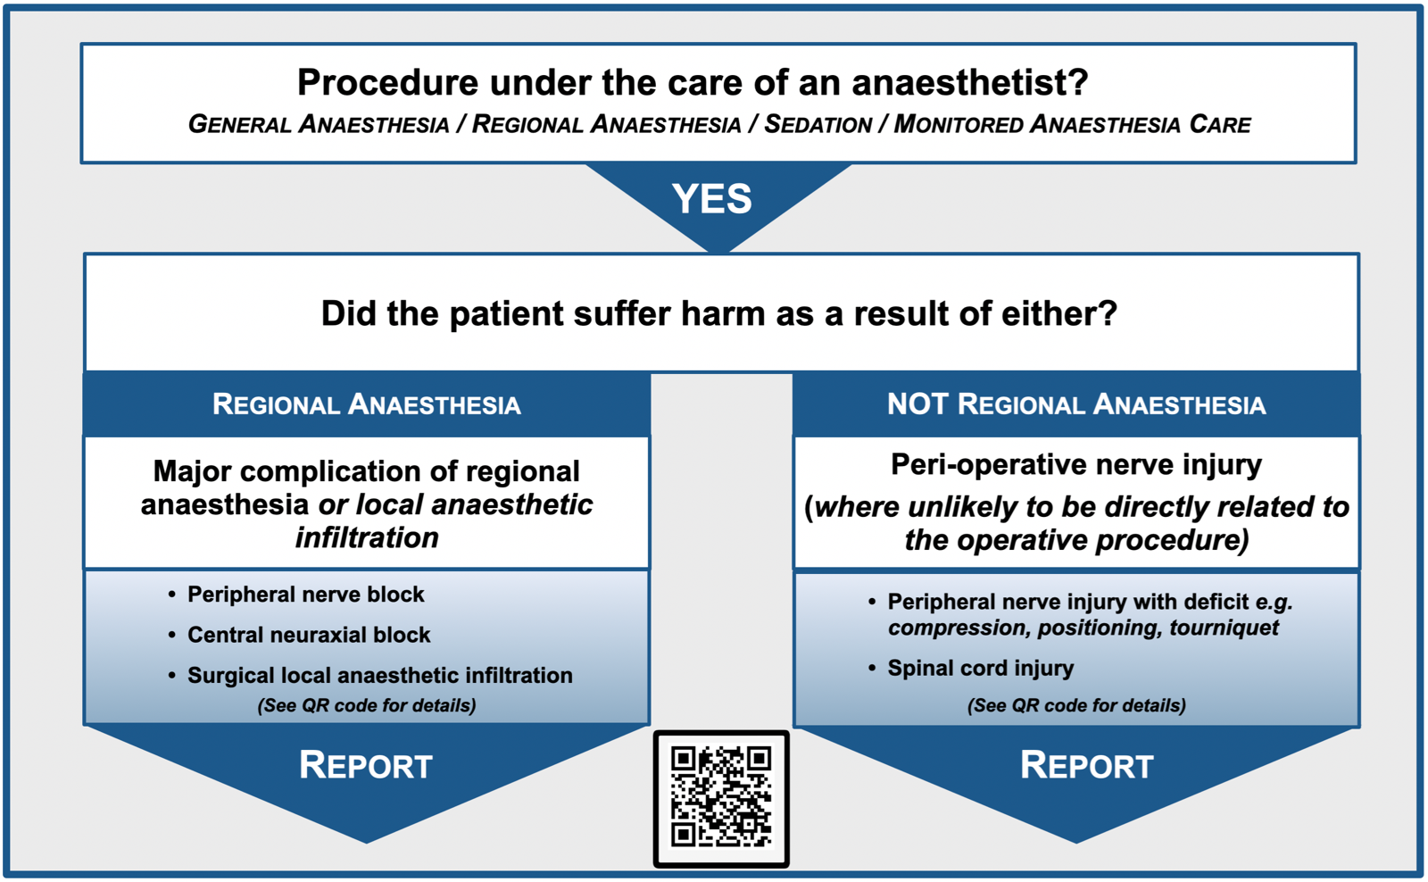
- The patient must be under the care of an Anaesthetist or Physician Assistant in Anaesthesia (PAA) at the time of the index procedure.
  - All adults and children
  - General anaesthesia, regional anaesthesia/analgesia, local anaesthesia or monitored anaesthesia care (i.e. care by an anaesthetist but without administration of anaesthetic drugs) are all included.
    - This includes all elective and emergency surgical procedures and/or anaesthesia undertaken in main, trauma, day surgery theatres and maternity (labour ward and obstetric theatres)
    - All isolated sites (e.g. for electroconvulsive therapy)
  - Interventional pain procedures in clinic or operating theatre
  - All regional anaesthetic procedures in intensive care
  - Any anaesthetic, sedation, or regional anaesthetic/analgesic procedure administered by an anaesthetist/PAA in the Emergency Department
  - Any regional anaesthetic/analgesic procedure administered by an anaesthetist/PAA for any other indication, including in intensive care or the wards e.g. rib fracture analgesia.

- The patient must present with one of the NAP8 complications, either:

  - Regional anaesthesia (RA) – related:
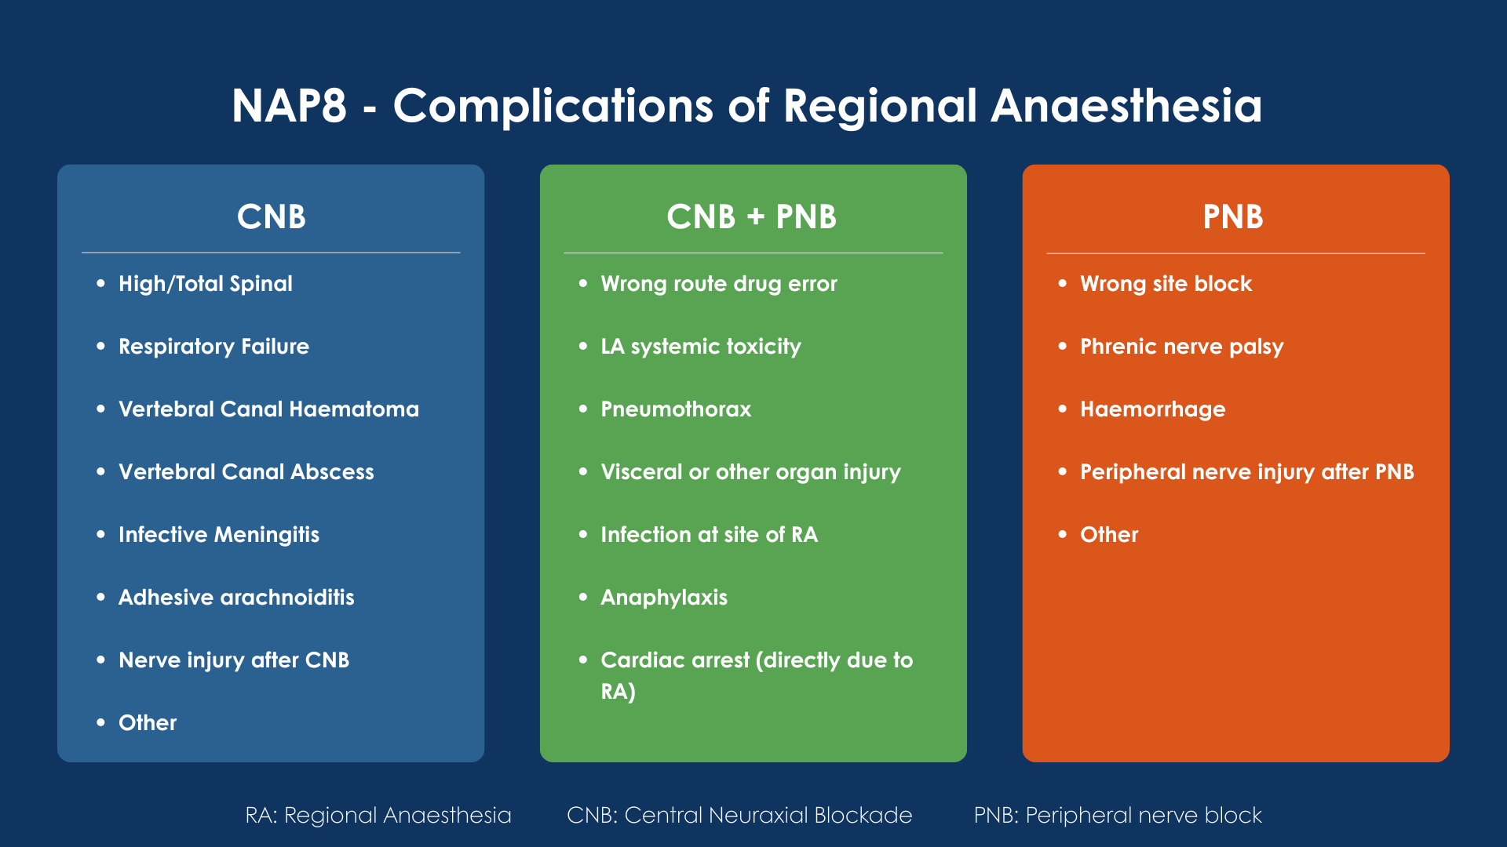
  - Non-RA related:
    - perioperative spinal cord injury following GA/Sedation/MAC where unlikely to be directly related to the surgical procedure
    - peripheral nerve injury following GA/Sedation/MAC where unlikely to be directly related to the surgical procedure i.e. compression, positioning or tourniquet

- The complication must present during the case registry period (18/05/2026 – 17/05/2027) even if the procedure occurred prior to this period
See the [Full definitions of complications reportable to NAP8] in the Appendix for a full description of NAP8 complications

NAP8 Exclusion criteria
Any complications arising in the following clinical scenarios fall outside the scope of NAP8 and should not be reported:
- Any complications presenting after the end of the case registry period, even if the original procedure was performed within the case registry period
- All procedures on critical care except for regional anaesthetic/analgesic procedures (see inclusion criteria)
- Intra- or inter-hospital transfers
- Any regional anaesthesia procedure performed by someone who is not either an Anaesthetist or a Physician Assistant in Anaesthesia, or is not a healthcare professional performing the procedure under the overall supervision of an anaesthetist
  - e.g. blocks performed by emergency medicine physicians are excluded; but blocks performed by pain nurses under supervision of anaesthetist/pain physician would still fall within the NAP8 scope and should be reported
- Lumbar punctures
All exclusions do not apply if the patient has already met, or later meets, inclusion criteria
If in doubt, please report. If you have any questions the NAP team will put you in touch with an independent moderator with whom you can discuss the case. Please email nap@rcoa.ac.uk should you require this.

The case-reporting process
Cases should be reported as soon as possible after a complication has occurred. This will ensure any details relying on recall are as accurate and complete as possible. All reports will be anonymous and confidential.
The following complications below will also trigger a follow up email at 6 months:
- General anaesthesia/MAC/sedation
  - Peripheral nerve injury
  - Spinal cord injury
- Regional anaesthesia
  - Vertebral canal haematoma
  - Vertebral canal abscess
  - Nerve injury after central neuraxial block (CNB)
After CNB
After PNB
  - Adhesive Arachnoiditis
  - Peripheral nerve injury after peripheral nerve block (PNB)
  - Anaphylaxis
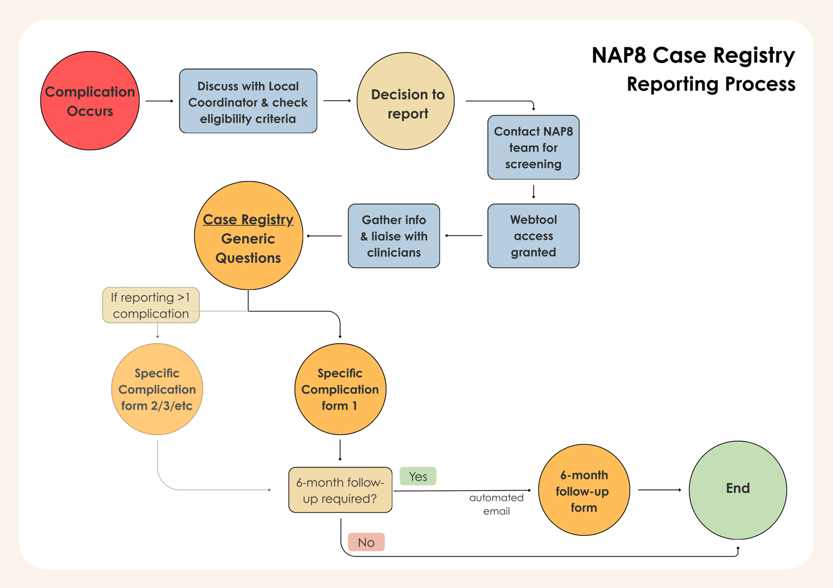
This will allow the NAP8 team to classify if the injury is permanent or not, or in the case of anaphylaxis to follow up on any allergen testing results.
Flowchart of Reporting Process - Figure 1
Flowchart of Reporting Process - Figure 2

1. Initial evaluation of case and decision to report
Local reporters should check the eligibility of the case using the general inclusion/ exclusion criteria listed above, as well as the complication-specific inclusion/exclusion criteria (see Appendix for full definitions of complications). If there are any doubts, please liaise with the central NAP8 team. If necessary, we will put you in touch with an independent moderator to discuss your case.
Please check to ensure that the case has not been reported by another team – this is crucial in cases involving multiple sites (e.g. an index procedure in a hospital, but a tertiary hospital managing the complication; or a complication moved from an independent sector site to the NHS). LCs from each site involved should liaise and ensure only a single report is submitted. The NAP8 team can put you in touch with LCs at other sites if necessary.
In most cases the site where the suspected index surgical/anaesthetic event that led to the complication should probably report the case, as there may be pertinent clinical details to report which are not commonly recorded in summary documents (e.g. procedural details not included in discharge summaries). This may involve requesting details from the other site (e.g. imaging reports, subsequent operation notes, specialist assessments).

2. Contact NAP8 team
- Email the NAP8 inbox (nap@rcoa.ac.uk) and state which NAP8 complication(s) are being reported (a workplace email is required).
- You will be provided with screening questions and asked to confirm the case meets these criteria.
- If the case meets screening criteria, access to the NAP8 Case Registry website will be issued.

3. Prepare the relevant case documentation
Please collate relevant clinical documentation and have it to hand. Participation/input from the anaesthetists and/or surgeons directly involved in the initial case is expected. This will involve discussion of the case in detail with the anaesthetist(s) involved, and you will likely need to work together to enter the data.

3.1 Overview of data collected
An illustrative outline of the information being collected by the case-report form is outlined below to help local reporters prepare the relevant information required.

(Sections highlighted in blue are subject to conditional logic and will only appear if relevant to the case)

Generic questions (all case reports):
Category of data | Additional description
Screening questions | Time/date of complication presenting
Site And Reporter Information | NHS/HSE vs. Independent; Number of sites involved; Role of reporter
Clinical Narrative | Timeline of key events, clinical presentation with relevant findings, investigations, management
Patient Details | Age, Sex, ASA grade, Ethnicity
BMI / Weight | BMI range; Paeds - Weight centile data & Exact weight
Pregnancy | 10-65yo females: Pregnancy status; pregnancy-related comorbidities
Patient Comorbidities | Checkbox list of comorbidities; Clinical Frailty Scale; Previous surgery; presence of sepsis
Perioperative medications inc. Anticoagulation | Baseline/perioperative anticoagulation; Time since last dose of anticoagulation; investigations; Reversal agents  Any other relevant pre-operative medications
Procedure Details | Day of week & time, location, specialty and type of procedure; grade and NCEPOD priority of surgery; specific details of procedure (e.g. approach, open/laparoscopic, blood loss, unplanned surgical steps/events, hypotension); peri-op critical care
Anaesthetic Details | Intended conscious level; Patient position(s) during operation; Tourniquet use; Anaesthetic techniques (Tickbox selection of technique(s) used e.g. General anaesthesia, Spinal, Epidural, Peripheral nerve block, Epidural Top-Up, Surgical local anaesthetic infiltration etc.)
Peripheral Nerve Block Details | Laterality, location and name of peripheral nerve block  Operator(s): grade, supervision, self-assessed ability  Conscious level and position during block,  Aseptic technique, Needle characteristics, single-shot/catheter  Prep-Stop-Block / safety time-out, Timing of block in relation to spinal,  Single shot vs. catheter, Nerve identification technique,  Needle characteristics  No. of needle passes  Drugs used - LAs (name, % and volume), adjuncts (name and dose)  Technical challenges encountered and intra-procedure events/complications
Central Neuraxial Techniques (Spinal, Epidural, CSE, Caudal) | Procedural details similar to PNB  Midline/paramedian, interspace level, preservatives in drugs  Epidural space identification technique, use of ultrasound, CSE type
*Epidural Top-up | Drugs used
Drugs (LA Infiltration) | Drugs used
Airway And Breathing | Airway and ventilation techniques
Intraoperative Monitoring | Monitoring modalities, spinal drain, supervision level, duration of procedure
Unplanned GA for RA case | Timing and reason for unplanned GA if regional was primary anaesthetic technique
Presentation of Complication | Timing of presentation relative to perioperative events, location, team/system that detected complication, relevant local system/policy, delays
Consent and Risk | Documentation and descriptors for pre-op discussion of reported complication’s risk
Outcomes after complication | Outcome of hospital episode, length of stay, unplanned critical care, surgical outcome, additional interventions  (Obstetrics: details on pregnancy term, labour, location and method of delivery, APGAR, cord gases, NICU)
Function after complication | Discharge destination, functional outcomes, severity of harm, employment
Standard of care | Any relevant (and adherence to) guidance, learning response/investigation, communication with patient
Contributory Factors Framework | Situational Factors, Local working conditions, Communication & culture, Organisational and External factors that may have contributed to the outcome
Complication-specific sub-forms | Clinical Presentation  Investigations – laboratory, imaging, specific (e.g. neurophysiology)  Management  Outcomes

Complication-specific forms:
Complication | Additional data
Anaphylaxis  + 6month follow-up | Drugs/Allergens used in peri-operative period, referral timeline to allergy clinic and testing, Allergen testing and results, timeline of events and interventions
Arachnoiditis  + 6month follow-up | Neurological investigations, additional details for neuraxial procedure and medications, other neuraxial interventions/devices, neurological and functional outcomes, residual deficits
Cardiac arrest | Cardiorespiratory comorbidity and tests, details of resuscitation, timeline of events and interventions
High/Total/Complete spinal + 6month follow-up | Height of patient, further details of neuraxial procedure, timeline of events and interventions
Infection, Infective meningitis, Vertebral canal abscess | Previous procedures, antibiotic prophylaxis, other infections, RA catheter follow-up and events, microbiology and imaging findings, interventions, subsequent neurological or other deficits
Local anaesthetic systemic toxicity | Other relevant medical and medication history, details of LA dosing and administration, management including lipid emulsion, cognitive aids, timeline of events and interventions
Nerve injury after Central neuraxial block  + 6month follow-up | Detailed neurological history and exam, further details of neuraxial procedure, medications, intraoperative factors (e.g. padding, hypotension), post-operative factors (e.g. casts, ICU stay), neurophysiology tests, referral to specialist
Other complication  + 6month follow-up | Further details of regional anaesthesia procedure, medications, outcome related to complication
Spinal cord injury (after GA/sedation/MAC)  + 6month follow-up | Detailed neurological history and exam, medications, intra-operative factors (e.g. padding, hypotension), post-operative factors (e.g. casts, ICU stay), neurophysiology tests, referral to specialist
Peripheral nerve injury (after GA/sedation/MAC)  + 6month follow-up | Detailed neurological history and exam, medications, intra-operative factors (e.g. padding, hypotension), post-operative factors (e.g. casts, ICU stay), neurophysiology tests, referral to specialist
Peripheral nerve injury after Peripheral nerve block  + 6month follow-up | Detailed neurological history and exam, further details of RA procedure and surgery, medications, intra-operative factors (e.g. padding, hypotension), post-operative factors (e.g. casts, ICU stay), neurophysiology tests, referral to specialist
Phrenic nerve palsy | Further details of RA procedure, other potential contributory causes, investigations, timeline of events and interventions
Pneumothorax | Further details of anaesthesia and RA procedure, surgical procedure; other potential contributory causes
Respiratory failure (after neuraxial opioids) | Other potential contributory causes (e.g. drugs in last 24 hrs, drug errors), timeline of events and interventions
Vertebral canal haematoma  + 6month follow-up | Pre-op medications, detailed neurological history and exam, follow-up, investigations, timeline of events and interventions
Visceral injury | Ocular vs. non-ocular injury  Ocular: detailed ophthalmological history, further details of RA procedure.  Non-ocular: further details of surgical procedure, other potential contributory causes
Wrong route error | Further details on error e.g. route, dose; detection process
Wrong site block | Actual vs. intended block, prep-stop-block, peri-procedural factors,

4. NAP8 Webtool overview and case-reporting instructions
The case-reporting webtool comprises of closed questions as well as a request to provide a narrative of the events, including factors leading up to complication as well as post-complication management and outcomes.
Go to: Flowchart of Reporting Process - Figure 1
The reporting form is divided into two sections:
- Generic questions
- Complication-specific forms
You will be asked to complete and submit the generic questions before moving on to the complication-specific questions.
After submitting the generic questions, you will be presented with the full list of reportable complications. In most cases there will only be one complication to report - click the relevant link, which will open a new window containing a set of questions specific to that complication. Please complete these questions and click submit.
If more than one complication occurred (e.g. local anaesthetic systemic toxicity leading to cardiac arrest) the link for each complication must be clicked. Each corresponding form will open in a new window and will need to be completed and submitted. You may choose to click and launch all relevant forms simultaneously; or complete and submit one (e.g. LAST) before returning to the list page to launch the next form (e.g. cardiac arrest). Please work through the questions on each complication form and click submit.
Webtool features:
- The NAP8 webtool is generally compatible on all electronic devices with access to the internet; completion on a computer is recommended.
- Save and continue function:
  - You will be able to save progress on the form using a “Save and continue” button located at the bottom of each page
  - This will generate and email a specific link to retrieve the partially completed form.
  - Please save periodically as you work through the form and keep the email/link generated safe - this is the only reliable way you can access a partially completed set of generic questions if you do not complete it in one sitting.
    - Please check the spam/junk folder and move the email to your inbox or retrievable location
    - Due to the anonymous nature of NAP reporting, the NAP team will have no way of retrieving this link or partially completed forms that have not been “submitted”
- Email with list of complication-specific forms:
  - On completing the generic questions, you will be asked to provide your email address so that an email with links to access the complication-specific forms can be sent to you.
  - This will allow you to launch the other complication forms if there is more than one being reported, and to complete the complication-specific forms on a later date.
- The email addresses are encrypted and held within the webtool system and the NAP team will not have access to this data.

Explanatory notes of specific sections are presented below to aid the reporting process, in the order they appear on the form.

4.1 Universal screening questions for NAP8
There will be a mandatory section to confirm that the case being reported meets the generic NAP8 criteria. Complication-specific screening questions will be presented later.

4.2 Selection of complication(s) being reported
Please select all the applicable complications being reported at the start of the form. There is a linked document to re-check the inclusion/exclusion criteria – ensure that the case meets the definition of a reportable NAP8 complication.
There may be a subset of cases where a case involves multiple complications reportable under NAP8. Examples include cardiac arrest as an endpoint from complications such as LAST or from high/total spinal. Please select ALL that apply.

4.3 Clinical Narrative
Please include sufficient information for the panel to understand the case and assess the contributory factors leading to the outcome. This would include:
- a timeline of key events,
- clinical presentation (relevant history and examination findings, including important relevant negatives)
- investigations
- management
There may be some overlap with the structured questions which follow. Please still complete these questions as instructed. Please do not include any identifiable information on the patient, staff or hospital(s).

4.4 Generic Questions
You will now be asked to fill out generic questions that are asked about every complication. This will include details about the patient, surgical procedure, any regional anaesthesia procedure(s) and the anaesthetic, outcomes and any contributory factors. Some of these questions are compulsory, others are not. Please answer as many of the non-compulsory questions as possible.

4.4a – Regional Anaesthesia procedural documentation
- Please document any attempted/abandoned blocks
- Please document any peripheral or central neuraxial block or that has been repeated or re-sited
  - If a block fails and requires to be repeated/re-sited at a later timepoint (e.g. a re-siting of a perioperative or labour epidural, or re-performing a peripheral nerve block in recovery) please document this as a separate procedure. This will generate a set of questions relating to the original and the repeat block.
  - There is a question on the procedure form to confirm if the block was a re-site
- Please complete the forms within each block type in chronological order e.g. (1) initial labour epidural (2) re-site of epidural
- If there has been a mix of different techniques, please ensure the order of the blocks has been described in the clinical narrative.
  - e.g. two labour epidurals were sited; spinal performed for subsequent Caesarean section.
- >4 Peripheral nerve blocks – select check box for “More than 4 blocks”
  - document the first 4 PNBs on the generic questions form
  - After the generic questions have been submitted and subsequently the list of complication-specific forms are presented – there will be a link to launch and complete the documentation of the other blocks

4.4b - Contributory factors framework
The case registry form includes a section to explore contributory factors, adapted from the Yorkshire Contributory Factors Framework (YCFF). The YCFF was developed by researchers with input from clinicians, risk managers and human factor experts as a framework for accident causation in hospitals, and a tool for incident investigation.
Healthcare is often delivered in complicated systems and situations, and this framework may help us develop a more nuanced understanding of the factors that cause the incident. Clear identification of contributory factors will help optimise learning and offer opportunities to address the causes of incidents more effectively for the future benefit of patients.
Please carefully consider the case along with involved clinicians to help identify any possible factors that may have contributed to the clinical course.

4.5 Complication-specific questions
After completing the generic questions, you will arrive at a page to “submit” the answers.
After this submission a menu of options will appear, with additional links to the specific complication(s) you would like to report. This menu will also be emailed to the reporter to allow access at a later time-point and in case the window is accidentally closed.

Case involved one complication only:
- In the majority of cases there will be just one complication to report and so please click the relevant link.
- This will open a new window containing a set of questions specific to that complication. Please complete these questions and click submit.
Case involved two or more complications:
- If more than one complication occurred (e.g. local anaesthetic systemic toxicity leading to cardiac arrest) both links need to be clicked and the corresponding forms completed.
- (Depending on browser settings) After the clicking on the 1st link, the user is usually be brought to the 1st complication form (e.g. LAST) - finish and submit the form.
- Return to tab/window with list of complication-specific forms and click on the other complication(s) to report, and submit the form(s) after completion.
  - If you have accidentally closed this window – you should have received the email with the list of complication-specific forms – click on the complication there to launch the linked form and complete it.
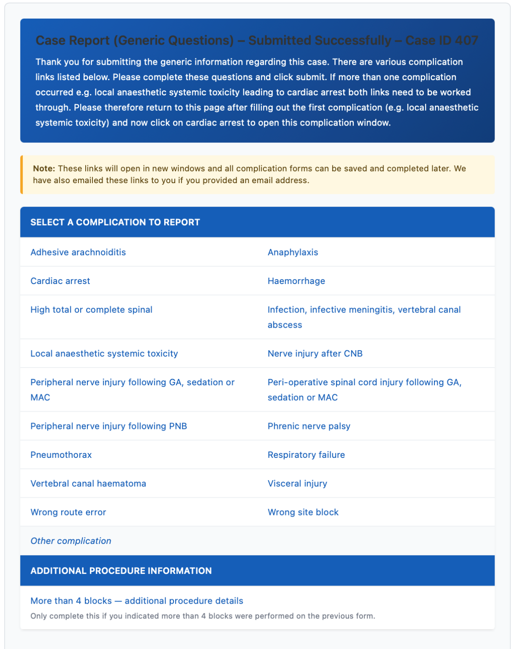
Figure 1: List of Complication-specific forms
Please note that a valid and complete NAP8 report requires the submission of the complication-specific questions as well.

4.5a Complication-specific Timeline Tool – explanatory notes:
In all case reports the clinical narrative in the generic questions should aim to cover the timeline of events, including contributory factors, the peri-procedure events, complication developing, and subsequent investigations and management.
In some of the complications being reported the exact timeline of exposures, clinical events, drugs and interventions may be crucial to the assessment and interpretation of the scenario.
A timeline builder is also added to the complication-specific reporting forms for the following complications:

- Anaphylaxis
- Cardiac Arrest
- High/Total/Complete spinal
- LAST
- Phrenic nerve palsy
- Respiratory failure after neuraxial opioids
- Vertebral canal haematoma

Please follow the instructions on each form as there are modifications for each complication.
In general:
- time 0 is designated as the start of the RA procedure or induction of general anaesthesia
- Insert relevant items (events, drugs/interventions) as requested, in chronological order.
Example:
Day/Time | Event
-36hrs | Enoxaparin 40mg (prophylactic dose)
0 | Epidural inserted
+16hrs | Epidural catheter removed
+22hrs | Weak legs on clinical review
+25hrs | MRI scan

5. Follow-up at 6-month timepoint
Depending on the complication type you will receive an automated reminder at 6 months with a link to access the 6-month follow-up form.
Please use the function explained below (Section 6) to view your case submission if you would like to remind yourself what has been submitted so far.
The 6-month follow-up forms are complication-specific but will include a narrative addendum freetext question if you would like to add to or amend the clinical narrative.

6. Monitoring and Retrieval of partially completed reports
There is a functionality on the website to look at the partially completed reports tied to the reporter’s email address.
Instructions:
- Access via: “My Cases” button on main NAP8 webtool
- Email verification to sign-in
  - Enter the email address used
  - If that email address matches any submitted cases, the user will be asked to complete an authentication process via email (check spam/junk folder)
- If the correct code is entered, they will be presented with a list of cases
  - Case ID generated on submission of the generic questions form
- Possible actions:
  - View the generic questions form (view-only; click on ‘View Case’)
  - Check and complete any complication-specific forms that are required
  - If the complication requires a follow-up and 6 months has elapsed from the date of the immediate complication-specific form submission
    - A link will be available to complete the 6 month follow up form

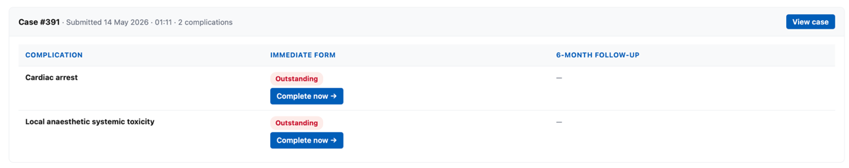
Example: Complication-specific forms yet to be completed

Example: Complication-specific form submitted; 6-month follow-up form pending
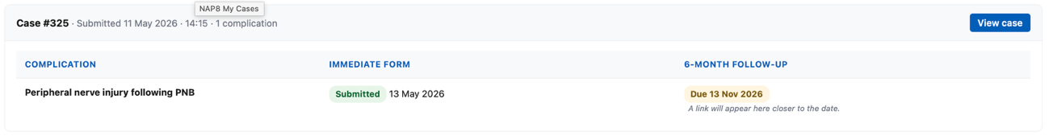

7. Troubleshooting the webtool
If you encounter any issues – please check if there is an explanation in this guide. Otherwise please contact the NAP inbox (nap@rcoa.ac.uk) and we will assist you. We will put you in touch with the NewcastlePROMS team (webtool administrators) if there is a technical issue to resolve.

Appendix

Full definitions of complications reportable to NAP8

Regional Anaesthesia-related complications
Complication | Inclusion criteria | Exclusion criteria | Comments
Either CNB or PNB
Wrong route drug error | Intravascular administration of a medication that was intended for perineural, intrathecal or epidural administration.  OR  Perineural, intrathecal or epidural administration of a medication that was intended to be administered by another route. |  | NHS Never Event therefore report irrespective of whether physical or psychological harm was incurred
Local anaesthetic systemic toxicity (LAST) | Administration of local anaesthetic by a surgeon for anaesthesia/analgesia AND/OR administration of local anaesthetic by an anaesthetist, by bolus or infusion for regional anaesthesia/analgesia.  AND EITHER  Clinical features of moderate to severe LAST e.g. seizure, loss of consciousness, cardiac arrhythmia* or cardiac arrest.  OR  Administration of lipid emulsion therapy. | Possible local anaesthetic toxicity which did not meet a threshold of at least moderate harm (for example patient report of circumoral tingling, tinnitus).  LAST secondary to sole use of intravenous lidocaine for pain procedures or peri-operative analgesia (i.e. not in conjunction with central neuraxial block, peripheral nerve block or surgical local infiltration).  Topicalisation of airway for awake tracheal intubation where no airway nerve blocks have been performed | * Cardiac arrythmia requiring unplanned monitoring, haemodynamic instability, and/or active intervention
Pneumothorax | New presence of air in the pleural cavity confirmed on radiological investigation  OR  New presence of air under tension in the pleural cavity requiring immediate decompression following a regional procedure with no time for radiological confirmation | Pneumothorax arising as an expected outcome following surgery (for example thoracic surgery) concurrent with central neuraxial or peripheral nerve blockade.
Cardiac arrest directly due to central or peripheral regional anaesthesia | Five or more chest compressions or use of defibrillation.  OR  Withdrawal of care during procedure or in recovery  OR  Died during anaesthesia care or in recovery | Cardiac arrest, withdrawal of care or died during procedure or treatment but cause not directly related to regional anaesthesia.
Infection at site of central or peripheral regional anaesthesia | Infection occurring within 30 days at or near the site of a previous peripheral nerve or central neuraxial block, either single shot or catheter, leading to localised abscess, discitis, osteomyelitis, systemic infection, or necrotising fasciitis.  AND  Required antibiotic therapy.  AND EITHER  Positive contributory micro-organism culture taken from either blood, abscess, or site swab.  OR  Imaging or clinical suspicion consistent with infection due to the central neuraxial or peripheral nerve block. | Insertion site inflammation or localised cellulitis.  OR  Catheter or insertion site colonisation (culture-positive perineural or epidural catheters but with no clinical evidence of site infection or requirement for antibiotic therapy).  OR  Vertebral canal abscess and infective meningitis (reported separately).
Anaphylaxis | Life-threatening anaphylaxis* confirmed to be secondary to local anaesthetic, another drug mixed with the local anaesthetic administered during the central neuraxial or peripheral nerve block, or to skin preparation solutions for block performance** | Anaphylaxis confirmed by allergen testing to be secondary to any drug used for sedation or general anaesthesia in a patient who had a concurrent central neuraxial or peripheral nerve block | *Unexpected severe hypotension  AND/OR  Severe bronchospasm  AND/OR  Swelling with actual or potential airway compromise  OR  Cardiac arrest  **Please log the anaphylaxis in the NAP8 case registry at the time of presentation. An automatic alert will be sent at 6 months to please review the patient case notes, log in and follow instructions to record if anaphylaxis has been confirmed as being secondary to any components of the regional anaesthesia technique.
Visceral or other organ injury | Inadvertent traumatic needling injury to a visceral or other organ, whether recognised at the time or afterwards. | Vascular, neurological or pleural injury are separate complications and should be reported elsewhere | Examples include liver capsule penetration leading to haematoma during transverse abdominis plane (TAP) blockade, bowel perforation during abdominal wall block, globe perforation during peribulbar blockade.
CNB

High/total/complete spinal | Any patient who develops a high block in association with central neuraxial anaesthesia/analgesia which is associated with requirement for ventilatory support* or cardiopulmonary resuscitation**.  OR  Any patient who develops a high block from epidural or intrathecal spread of local anaesthetic following a peripheral nerve block |  | * Ventilatory support includes the additional use of ‘bag/mask’ ventilation, or ventilation assisted by the use of a supraglottic airway device or endotracheal tube  **Cardiopulmonary resuscitation includes the use of basic and advanced life support
Respiratory failure | Any patient who develops respiratory failure due to neuraxial opioids which is associated with requirement for ventilatory support*  AND  Neuraxial opioids either intrathecal or epidural, via either single shot or continuous catheter | Respiratory failure secondary to high/total/complete spinal should be reported elsewhere  Patients requiring supplemental oxygen or naloxone | *Ventilatory support includes the additional use of ‘bag/mask’ ventilation, or ventilation assisted by the use of a supraglottic airway device or endotracheal tube
Vertebral canal haematoma | Confirmed new inadvertent accumulation of blood in the extra-cranial intramedullary, subdural or epidural space | Purposeful injection of blood into the epidural space performed as part of dural blood patching.  OR  Vertebral canal haematoma presenting after spinal or neurological surgery and thought to have arisen as a surgical complication.
Vertebral canal abscess | Confirmed new infection within the extra-cranial intramedullary, subdural or epidural space. | Vertebral canal abscess presenting after spinal or neurological surgery and thought to have arisen as a surgical complication rather than from regional anaesthesia.
Infective meningitis | Clinical or laboratory diagnosis of infective bacterial or viral meningitis. | Infective meningitis presenting after spinal or neurological surgery.
Adhesive arachnoiditis | Arachnoid inflammation, intrathecal scars and dural adhesions, identified on radiological imaging
Nerve injury after central neuraxial block | Spinal cord ischaemia or infarction  OR  Direct spinal cord injury  OR  Direct radicular or other non-cord nerve injury (unintended new abnormality in one or more modalities - sensory, motor, pain or autonomic - lasting more than 48 hours after either a single shot technique or removal of a neuraxial catheter) | Cause agreed by local multidisciplinary team to be secondary to direct surgical injury or childbirth. In obstetric patients please do not report femoral, obturator, peroneal, lumbosacral or lateral cutaneous nerve of thigh neuropathies/plexopathies unless there is a clear likelihood that peri-operative positioning or the anaesthetic was responsible. If in doubt report.
‘Other’ complication not listed above | Radiologically confirmed intracranial infarction or haemorrhage occurring after CNB (including but not limited to: Subdural haematoma, subarachnoid haemorrhage, intraventricular haemorrhage, cerebral venous sinus thrombosis or pituitary apoplexy).  OR  Radiologically confirmed Posterior Reversible Encephalopathy Syndrome (PRES).  OR  Cranial nerve palsy, where intracranial haemorrhage or space occupying lesion has been excluded on radiological imaging.  OR  Any other complication secondary to central neuraxial block not listed above | Accidental dural puncture with or without epidural blood patch which does not result in any of the listed complications.
Peripheral nerve blocks
Wrong site block | A nerve block performed on the wrong patient or the wrong site, whether local anaesthetic was injected or not. |  | Never event therefore report irrespective of whether physical or psychological harm was incurred
Phrenic nerve palsy | Unplanned requirement for non-invasive or invasive ventilation  OR  Confirmed unilateral diaphragmatic weakness causing functional impairment more than 48 hours after either a single shot block or removal of a nerve catheter | The need for supplemental oxygen, but no requirement for non-invasive or invasive ventilation after regional anaesthesia.
Haemorrhage | Haemorrhage arising from a regional anaesthetic procedure.  AND EITHER  Required treatment with blood products  OR  surgery  OR  interventional radiological intervention. | Haemorrhage which requires observation or conservative management only (including manual pressure).
Peripheral nerve injury following peripheral nerve block | Unintended new abnormality in one or more modalities (sensory, motor, pain or autonomic) lasting more than 48 hours after either a single shot block or removal of a nerve catheter* | Cause agreed by local multidisciplinary team to be secondary to direct surgical injury or childbirth. In obstetric patients please do not report femoral, obturator, peroneal, lumbosacral or lateral cutaneous nerve of thigh neuropathies/plexopathies unless there is a clear likelihood that peri-operative positioning or the anaesthetic was responsible. If in doubt report. If in doubt report. | Abnormalities do not need to map to any particular nerve or radicular distribution.  Neurological abnormality may be a change of function in any specific modality (e.g. in the sensory modality both unintended new loss of sensation and new paraesthesia should trigger reporting)  *If a patient presents with a suspected nerve please log the nerve injury in the NAP8 database at the time of presentation. An automatic alert will be sent at 6 months to please review the patient case notes, log in and follow instructions. This information will be vital and will be used by the multidisciplinary review team to a) determine causality and b) to define the injury as permanent or not
‘Other’ complication not listed above | Any other complication secondary to peripheral nerve block not listed anywhere above

Link to Word document download of: [Definitions of RA-related complications 3/5/2026]

- Non-RA related complications

Complication | Inclusion criteria (must be met to trigger central reporting by LCs) | Exclusions | Comments
Spinal cord injury | Clinical signs and/or symptoms consistent with unintended or unexpected, new spinal cord injury at any level whether temporary or permanent  AND  Supported by radiological and/or neurophysiological investigations and/or clinical intervention e.g. surgical decompression, evacuation of haematoma, CSF diversion (lumbar/spinal drain and/or CSF drainage) based on clinical judgement | Injury directly related to surgical manipulation during spinal surgery  OR  Any injury consistent with direct surgical cord injury  OR  Any isolated intracranial cause which explains symptoms/signs  OR  Any case where preoperative neurological status could not be reliably assessed, making confirmation of a new injury following anaesthesia uncertain e.g. patient required intubation of the trachea by pre-hospital team  OR  Cause agreed by local multidisciplinary team, to be secondary to central neuraxial block (report under CNB complications) | Cases involving cross clamping of major vessels, cardiac surgery or endovascular work are to be included
Peripheral nerve injury  (general anaesthesia /sedation/MAC) | Unintended new abnormality in one or more modalities (sensory, motor, pain or autonomic) lasting more than 48 hours following the end of the procedure* | Cause agreed by local multidisciplinary team to be secondary to direct surgical injury or childbirth. In obstetric patients please do not report femoral, obturator, peroneal, lumbosacral or lateral cutaneous nerve of thigh neuropathies/plexopathies unless there is a clear likelihood that peri-operative positioning was responsible. If in doubt report.  OR  Nerve injury secondary to airway manipulation e.g. lingual or hypoglossal nerves secondary to laryngeal mask positioning  OR  Critical illness polyneuropathy following surgery and ICU stay | For example brachial plexus injury following Trendelenburg position; common peroneal nerve injury following lithotomy position; ulnar nerve injury due to compression; tourniquet related injury  Abnormalities do not need to map to any particular nerve or radicular distribution.  Neurological abnormality may be a change of function in any specific modality (e.g. in the sensory modality both unintended new loss of sensation and new paraesthesia should trigger reporting)  *Please follow standard care pathways including referral to neurological/surgical services, imaging and nerve conduction studies where deemed appropriate by local team.  Please log the nerve injury in the NAP8 database at the time of presentation. An automatic alert will be sent at 6 months to please review the patient case notes, log in and follow instructions. This information will be vital and will be used by the multidisciplinary review team to a) determine causality and b) to define the injury as permanent or not

Link to Word document download for: [Definitions of perioperative spinal cord or peripheral nerve injury following GA, sedation or MAC]

