
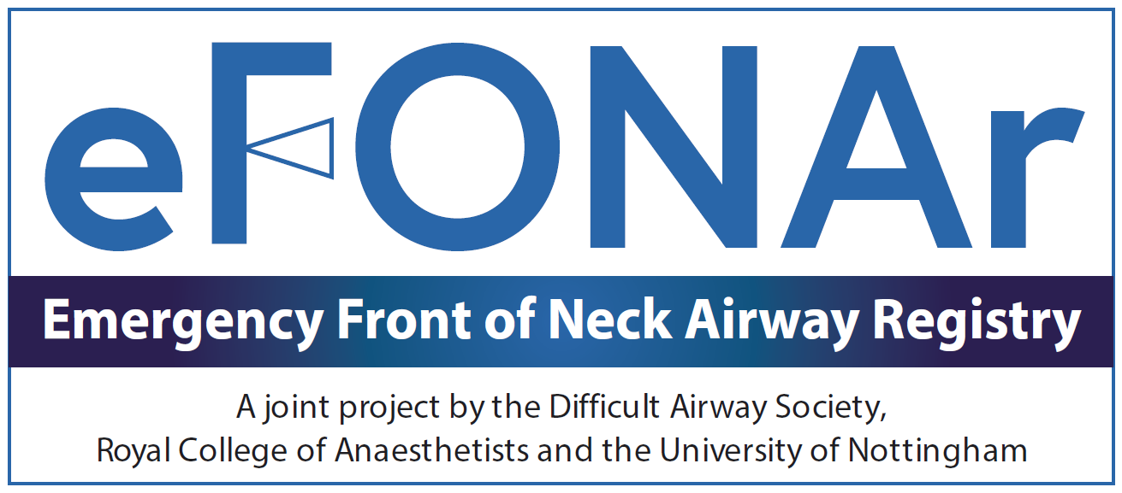

Scan the QR code for eFONA registry website

Had a Plan D?

The Emergency Front of Neck Airway Registry (eFONAr) will collect data on cases of eFONA from 1st January 2025. eFONAr follows on from the work of NAP4, which studied Major Complications of Airway Management in the United Kingdom.

Scan the QR code above for further information

