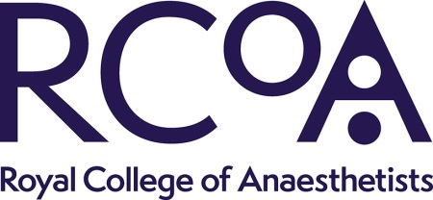

Royal College of Anaesthetists: QI Editor – Head and Neck, Regional and Vascular chapter

Application process
Closing date: 9am, Monday 15th July 2024
Please read the role description and person specification. If you believe that you are the right person for this role, please submit an abbreviated focused CV (maximum 2 pages) and a short statement (up to 650 words) advising why you would be interested and demonstrating any experience that would be relevant to supporting this work.
Please send your CV and statement to gpas@rcoa.ac.uk by 9am on Monday 15th July 2024 and specify whether you are applying for the Head and Neck, Regional or Vascular chapter.

Quality Improvement (QI) Chapter Editor
Job Description

Role | Chapter Editor (Head and Neck, Regional or Vascular), RCoA QI Book
Organisation | Royal College of Anaesthetists (RCoA)

Role description
Summary | The Chapter Editor will work in collaboration with the College QI Lead, GPAS authors and section writers.  Applicants will have an understanding of QI methodology and current QI priorities, along with guideline development and critical appraisal methods.  Applicants will ideally have experience working in the area of anaesthesia that the section covers. They will have experience of working with multi-professional committees or working groups. Strong interpersonal skills and excellent verbal and written skills are required, along with an ability to communicate complex issues to different audiences.  Once appointed, the Chapter Editors will be responsible for providing QI expertise to the GPAS authors and section writers, editing sections and approval of final draft. This will require working to publishing deadlines.
Responsibilities | The Chapter Editors will be supported by College staff, who will provide project management and administrative support. The Chapter Editors will also be supported by the College QI Lead.  General  - Agree a timeframe for development of the Chapter  - Complete a ‘Declaration of Interests’ form.  - Work with the College QI Lead as required at and between meetings.  Chapter Development  - Work with GPAS authors, section writers and College QI Lead to deliver the chapters to specified standard and layout.  - Make appropriate changes to the recommendations as requested.  - Accept or reject any proposed changes following consultation.  - Provide reasoning for rejecting a proposed change from consultation.  - Sign-off final version of the chapter before the College QI Lead and Clinical Quality and Research Board.
Conditions, e.g. time commitments, length of appointment | Chapter Development  - The majority of work will be via email, but Chapter Editors are expected to attend meetings (via MS Teams) as required.  - Suggest examples of QI methodology and worked examples for each chapter.  - Work to deadlines as agreed with College staff. The project is anticipated to take no longer than 12 months.

Person specification
Essential criteria
Experience | Holder of a post in Anaesthesia or dual ICM/Anaesthesia or equivalent, and able to demonstrate credibility with employer Credible level of experience of expert committee work or standards setting work in a relevant setting.  Experience developing guidelines or similar documents.
Skills | Evidence of excellent verbal and written communication skills. Ability to manage others in order to deliver work to deadlines.
Knowledge | A detailed knowledge of anaesthesia and specifically anaesthesia related to the chapter topic.  Understands the processes of QI methodology and QI priorities.
Other | Open to feedback and able to provide sound and tactful reasoning for accepting or rejecting any suggestions made during the chapter development process.

