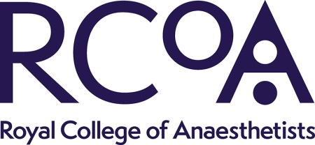

Royal College of Anaesthetists: Guidance for the Provision of Anaesthetic Services - Public Consultation Form
Please complete the table below with any comments you have on the draft Guidance on the Provision of Anaesthetic Services (GPAS) for the Regional chapter. Please send all completed forms to GPAS@rcoa.ac.uk
GPAS chapter: (delete as appropriate) |  | Regional Anaesthesia 2024
Organisation:
Page number  Or ‘general’ for comments on the whole document | Line number  Or ‘general’ for comments on the whole document | What the comment is
E.g.  15 | E.g.  45 | E.g.  We are concerned that this recommendation may imply that …………..

