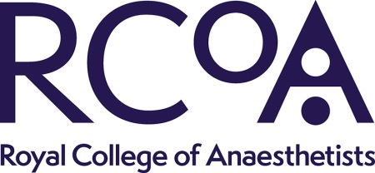 |  |  | Royal College of Anaesthetists  35 Red Lion Square  London WC1R 4SG  Tel: 020 7092 1500  Return application via email to: rkrishnian@rcoa.ac.uk

APPLICATION FORM
Title |  |  |  | Surname

Forenames
GMC number |  |  |  | College reference number
Address for Correspondence |  | Postcode
Contact daytime Tel/Mobile
Contact evening Tel/Mobile
Email address
Date available to commence employment?
(Please also include any intended holiday booked in the next 6 months)
Position Applied For | Bernard Johnson Advisor for Training

Statement in Support of your Application
Please indicate clearly why you want the role and how your skills and experience meet the requirements of the post as set out in the Job Description/ Person Specification
Additional Information
Please answer the following question:

Do you have any restrictions or warnings against you practising medicine within the UK (for example with the GMC)?

YES/NO

If yes, you must provide details:

Please indicate where you saw this post advertised?

Declaration
I confirm that the information given on this form is, to the best of my knowledge, true and complete. Any false statement may be sufficient cause for rejection or, if employed, dismissal.

Signature: Date: Click or tap to enter a date.

Please ensure that you include a two-page CV with your application.

