|  |  |  |
| --- | --- | --- |
| Vacancies | The Royal College of Anaesthetists |  |  |

**Independent Examinations Expert**

The Royal College of Anaesthetists (RCoA), Faculty of Intensive Care Medicine and the Faculty of Pain Medicine seek independent examinations expertise to provide ongoing advice, guidance, challenge and expertise to update its examinations.

The independent adviser will work alongside College stakeholders, committees and within College governance to provide on-going advice into a newly formed Examination Development and Assurance Group (EDAG), which will support the implementation of changes to the following postgraduate, professional examinations:

[Fellowship of the Royal College of Anaesthetists (FRCA)](https://www.rcoa.ac.uk/examinations/examination-reports-statistics/frca-internal-examination-review)

[Fellowship of the Faculty of Intensive Care Medicine (FFICM)](https://www.ficm.ac.uk/trainingexams/examinations)

[Fellowship of the Faculty of Pain Medicine (FFPMRCA)](https://fpm.ac.uk/training-examinations/ffpmrca-examinations)

All three examinations are managed by the Examinations Department within the RCoA.

**Background**

The examinations delivered by the RCoA are approved by the General Medical Council for delivery in the UK as part of the wider curricula and training programmes in Anaesthesia and Intensive Care Medicine.

Since 2021, two reviews of our examinations have been undertaken, an internal review of the FRCA examination and an independent review of all RCoA delivered exams. Links to these reports are included below.

Like many organisations the College and faculties needed to rapidly change the delivery methods of its examinations during the pandemic. During 2021, two issues occurred with the examinations which pointed to the need to improve processes, technology and suppliers, communication, data, and human factors. From our investigations at the time and the reviews of our examinations, we found other contributing factors that could be adding to the pressure on examination deliveries, and which may impact the utility of the examinations as defined in [Designing and maintaining postgraduate assessment programmes - GMC (gmc-uk.org)](https://www.gmc-uk.org/education/standards-guidance-and-curricula/guidance/designing-and-maintaining-postgraduate-assessment-programmes)

**Internal Review of FRCA Examinations (2020-2022)**

Over the course of the past 18 months, the College conducted a review of the FRCA examination; a summative, nationally standardised assessment in the [training programme](https://www.rcoa.ac.uk/training-careers/training-hub), integral to patient safety. Focusing on best practice, the review examined the underlying principles, structure and mode of the examination, which had not been fundamentally reviewed in the College for over 10 years.

The report on the [FRCA Internal Examinations Review](https://www.rcoa.ac.uk/examinations/examination-reports-statistics/frca-internal-examination-review) was published on 11 January 2023.

**Independent review of RCoA delivered examinations (2021-2022)**

The College commissioned an independent review of the FRCA, FFICM and FPMRCA examinations and the delivery infrastructure for the improved long-term utility and sustainability of the examinations. The review produced a report and a set of recommendations for the three examinations that will need to be prioritised and actioned.

[This report](https://rcoa.ac.uk/news/response-independent-review-assessment-processes-rcoa) was published on the 16 February 2023 with an executive summary linking both internal and independent reports.

**Examinations Development and Assurance Group**

The Examinations Development and Assurance Group (EDAG) is a new group within the College that will oversee the development of the exams and the implementation of recommendations from the two reports. We anticipate that the EDAG will meet on a monthly basis for the first 6-8 months in 2023, and then on a less frequent basis such as quarterly. The governance of the EDAG is illustrated below:

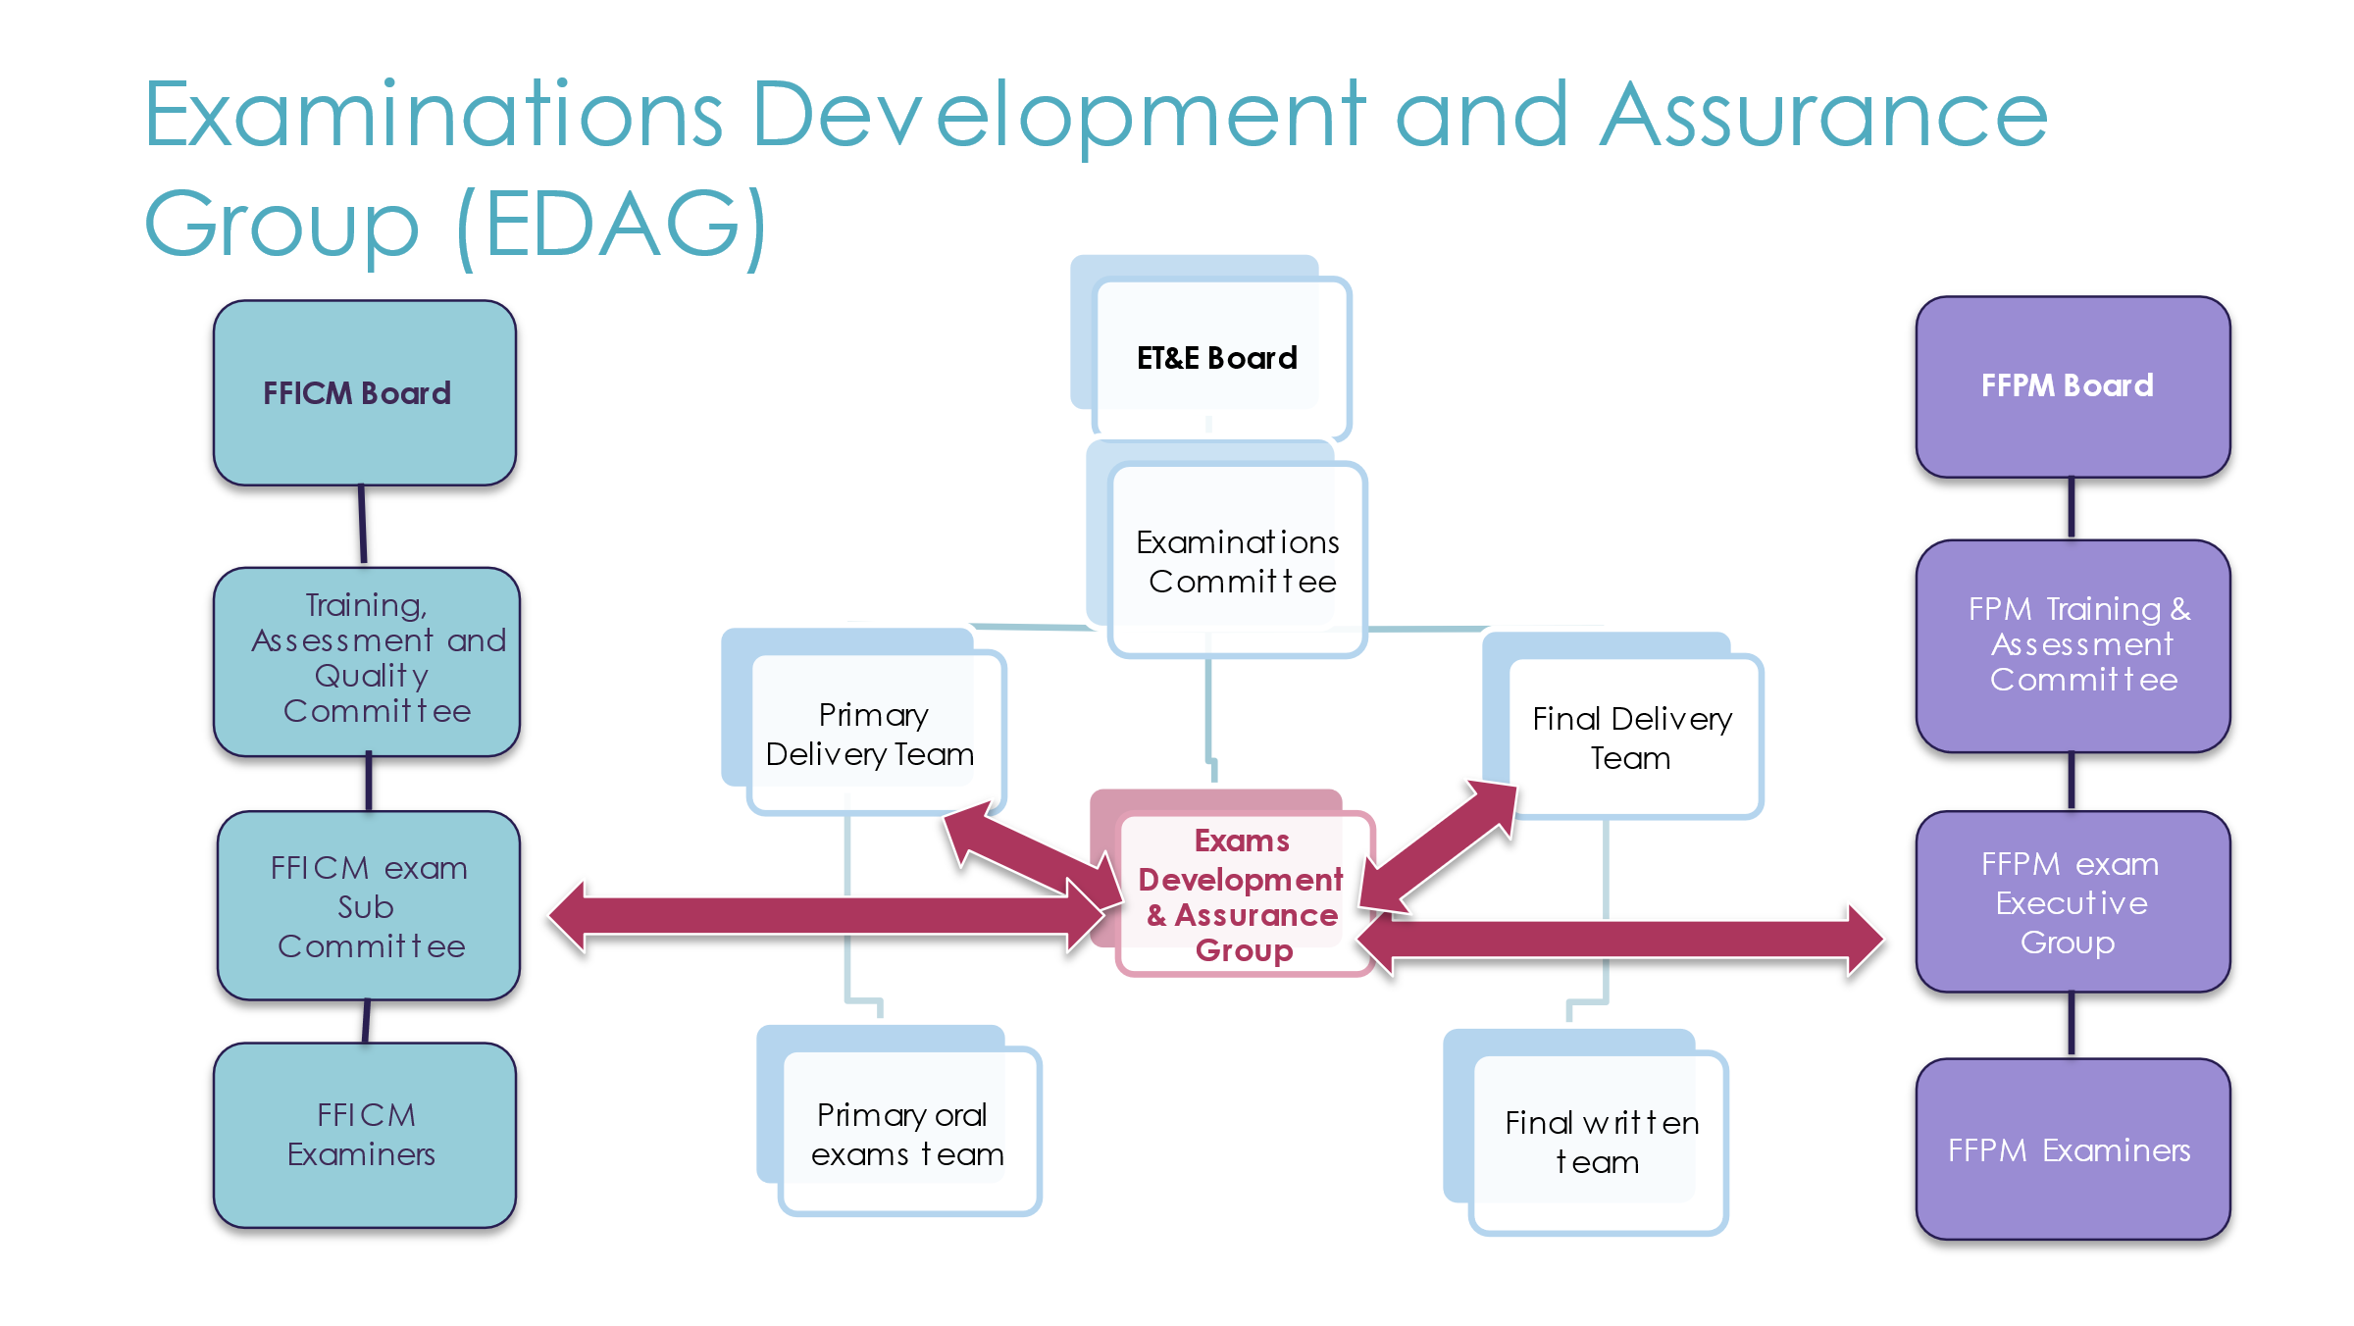

**Scope of the work requiring expert advice**

The scope of work for the role sought is broad and will cover the following areas:

* Assessment design
* Assessment modalities
* Processes
* Governance
* Delivery methods (online vs. remote vs. in person delivery)
* Standard setting, reliability and validity
* Academic research

The College values the views and experiences of Doctors in Training, candidates, examiners and those in the training community and would like the prospective applicants to consult with these stakeholders.

**Application process**

To apply for this role, please send a CV and supporting statement, which is no more than 2 sides of A4 and addresses the points below, to Fiona Daniels, Head of Examinations, at [fdaniels@rcoa.ac.uk](mailto:fdaniels@rcoa.ac.uk)

**Your supporting statement should make reference to:**

1. Relevant knowledge, skills and experience (experience of postgraduate medical assessment in core and higher training level is desirable).
2. Any projects, initiatives and activities associated to improving medical education and assessment.
3. How you will ensure best practice is maintained across our examinations whilst capturing the views of examiners, candidates and Doctors in Training as an integral part of this work.
4. How you will ensure commitment to the role.
5. Leadership capabilities.
6. Availability throughout the course of the year.
7. Costs (including full day rate).

**The** **deadline for application** **is** **5pm, Friday, 2 June 2023**.

For further information on this role, please email Fiona Daniels.