Capnography: Sustained Exhaled Carbon Dioxide Quiz Cards
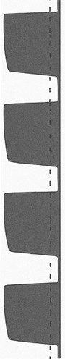
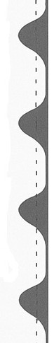
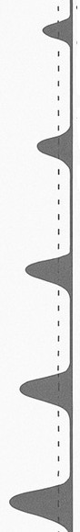
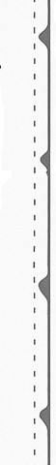
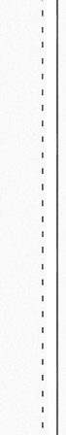




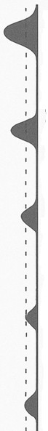
“Advanced” Capnography Quiz Cards
What might this represent?
What might this
represent?
What might this
represent?

We used the questions above to stimulate discussion for those clinicians more familiar with capnograph waveforms .
Can you name some other causes of an
absent capnography
trace, once oesophageal intubation has been
excluded?
What might you see if
capnography is in place with an airway during CPR?
How might capnography aid
How many capnograph
waveforms are needed to confirm tracheal
intubation?
Although we have general answers in mind, the main aim is to engage the audience with the training and were very open to any answers that could be justified.

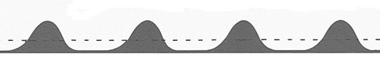
Intended answers (Left to Right)

- An attenuated trace may. This may or may not be appropriate depending on the clinical context.
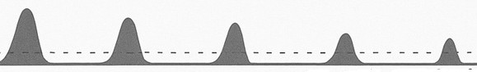
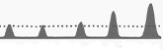
- Oesophageal intubation, gradually decreasing ETCO2 value – watch out if difficult mask ventilation prior to intubation
- ETCO2 in malignant hyperthermia or hypoventilation.

Chrimes et al, (2022), Preventing unrecognised oesophageal intubation: a consensus guideline from the Project for Universal Management of Airways and international airway societies*.
Anaesthesia, 77: 1395-1415. https://doi.org/10.1111/anae.15817

