
Capnography: criteria for Sustained Exhaled Carbon Dioxide

Both the intubator and assistant should independently assess the capnograph waveform for the following criteria to assess for sustained exhaled carbon dioxide.
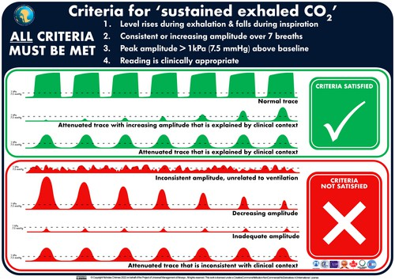

Chrimes et al, (2022), Preventing unrecognised oesophageal intubation: a consensus guideline from the Project for Universal Management of Airways and international airway societies*.
Anaesthesia, 77: 1395-1415. https://doi.org/10.1111/anae.15817

If any of the criteria are not met this should be declared to the team:

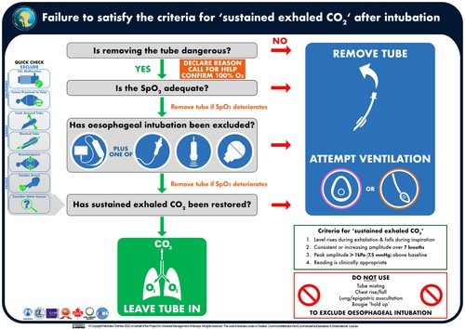
"I'm concerned that the tube is in the wrong place. We need to exclude oesophageal intubation."

