#HSRCConference | 
5 CPD credits | 
HSRC Conference 2021
Thursday 9 September 2021

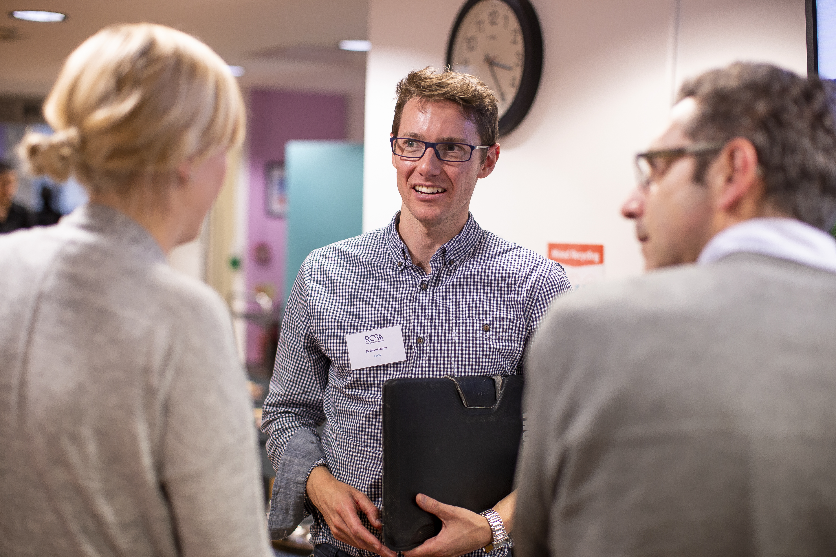
Venue: Online, Zoom
Registration: £75 for RCoA members (discounted rates available)
Clinical Content Leads: Professor Ramani Moonesinghe and Professor Iain Moppett

Join us for a day of presentations and panel discussions highlighting the latest updates and future plans on various HSRC projects and research in perioperative care. Including:
- The launch of the Perioperative Quality Improvement Programme (PQIP) Annual Report
- Updates from:
  - National Emergency Laparotomy Audit
  - Children's Acute Surgical Abdomen Programme (CASAP)
  - 7th National Audit Project
  - Sprint National Anaesthesia Projects 2 and 3.

Join senior NHS leaders to discuss our new research findings and cover high impact topics including risk prediction, enhanced care, socioeconomic deprivation and surgical service reorganisation.


HSRC conference 2021
Thursday 9 September 2021

09:45–09:55 | Joining and network checks
09:55–10:00 | Welcome and introduction | Professor Ramani Moonesinghe
Session 1: Breaking news (Chairs: Professor Ramani Moonesinghe and Professor Iain Moppett)
10:00–10:20 | PQIP annual report launch | Dr Kylie Edwards  Dr Georgina Singleton
10:20–10:40 | CASAP: Interim findings of the quality of care and outcomes of children undergoing emergency abdominal surgery | Dr Amaki Sogbodjor
10:40–11:00 | CAPO: Timing of surgery after myocardial infarction or stroke | Dr Matthew Luney
11:00–11:20 | Panel discussion  Prof Iain Moppett - HSRC Deputy Director  Prof Simon Kenny - NHS England National Clinical Director for Children and Young People  Prof Mark Davenport - Professor of Paediatric Surgery, Kings College Hospital  Dr Simon Courtman - Association of Paediatric Anaesthesia  Dr Chris Snowden - RCoA Clinical Lead (Joint) for Perioperative Medicine.
11:20–11:30 | Break
Session 2: What we have found so far… part 1 (Chair: Professor Iain Moppett)
11:30–11:40 | Core outcomes for perioperative and anaesthesia care in adults | Dr Oliver Boney
11:40–11:50 | Core outcomes for perioperative paediatric outcomes | Dr Cyrus Razavi
11:50–12:00 | Breakthrough pain during awake caesarean section | Dr Reshma Patel
12:00–12:10 | Predicting risk of mortality in adult inpatient surgery | Dr Danny Wong
12:10–12:20 | Using data to improve perioperative care: the POM-VLAD project | Dr James Bedford
12:20–12:30 | Barriers and enablers to engagement with quality improvement | Dr Duncan Wagstaff
12:30–13:00 | Panel discussion: Clinical impact  Dr Nuala Lucas – Chair of the Education Subcommittee, Obstetric Anaesthetists’ Association  Mrs Susanna Stanford – Lay Representative, Obstetric Anaesthetists’ Association  Dr Carolyn Johnston – Chair of the HSRC Quality Advisory Group  Professor Mike Grocott – NIAA Board Chair  Professor Suellen Walker - Chair of the Scientific Committee, Association of Paediatric Anaesthetists
13:00–13:45 | Lunch break
Session 3: What we have found so far… part 2 (Chair: Professor Ramani Moonesinghe)
13:45–13:55 | Socioeconomic status and outcome from emergency laparotomy | Dr Tom Poulton
13:55–14:05 | ICNARC-NELA enhanced care analysis | Dr LJ Spurling
14:05–14:15 | Emergency laparotomy and distance travelled to hospital | Dr Tom Salih
14:15–14:25 | Impact of COVID surge on anaesthetic activity | Dr Emira Kursumovic
14:25–14:35 | DrEaMing after major surgery | Dr Matt Oliver
14:35–14:45 | Critical care admission and outcome from surgery | Dr Tarush Thevathesan
14:45–15:15 | Panel discussion: Policy impact  Dr Alison Pittard – Dean, Faculty of Intensive Care Medicine  Dr Anna Batchelor – Past President, Intensive Care Society  Professor Neil Mortensen – President, Royal College of Surgeons  Dr Mike Prentice - Interim Medical Director (North), NHS England  Mrs Celia Ingham-Clark – Medical Director for Clinical Effectiveness, NHS England  Professor Chris Moran – National Clinical Director for Major Trauma, NHS England
15:15–15:30 | Break
Session 4: Forward look for the HSRC (Chairs: Dr Carolyn Johnston and Professor Ramani Moonesinghe)
15:30–15:45 | NAP7 | Dr Jasmeet Soar
15:45–16:00 | SNAP3 | Dr Claire Swarbrick
16:00–16:10 | NELA | Dr Dave Murray
16:10–16:20 | PQIP | Prof Ramani Moonesinghe
16:20–16:45 | Panel discussion: Future research and improvement priorities in perioperative care  Chair: Professor Iain Moppett – HSRC Deputy Director  Professor Mike Grocott – NIAA Board Chair  Professor Ramani Moonesinghe – HSRC Director  TBC – RCoA Council  TBC – Association of Anaesthetists  TBC – Centre for Perioperative Care
16:45 | Close
Programme and timings are subject to change. Please check the event webpage for up-to-date information.

