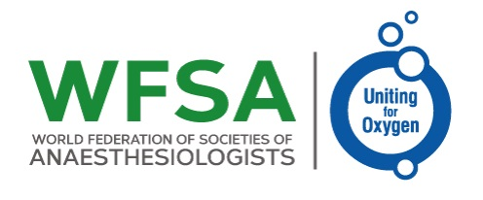

Uniting for Oxygen Appeal

Every year in low- and middle-income countries (LMICs), hundreds of thousands die from a lack of oxygen in hospitals, a situation made even more severe by the COVID-19 pandemic.  The WFSA Uniting for Oxygen Appeal aims to raise £100,000 to provide life-saving oxygen therapy equipment for hospitals in Nigeria and Zimbabwe. **Let’s unite to save lives**.

How the Appeal Works

WFSA are calling on the global anaesthesia community and others to support this fundraising appeal and help get oxygen to where it is most needed. **WFSA will match fund all donations** which will double every pound or dollar donated.

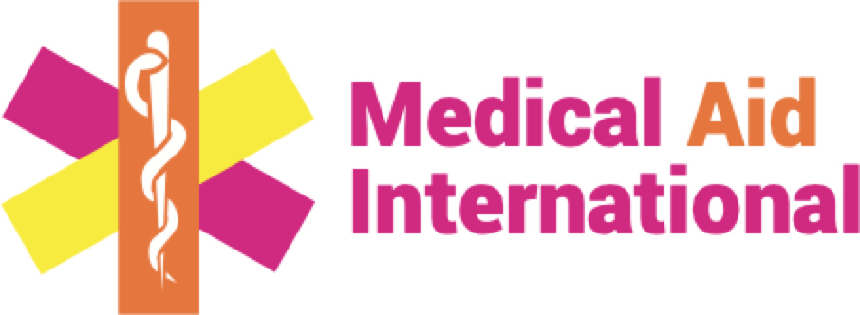

Working with Member Societies and the WFSA Africa Regional Section, WFSA have identified hospitals in Nigeria and Zimbabwe currently experiencing the most severe oxygen therapy shortages. Vital equipment and training will be provided in partnership with [Medical Aid International.](https://www.medaid.co.uk/)

What your donations will be used for

This appeal intends to raise sufficient funds to cover the costs and delivery of:

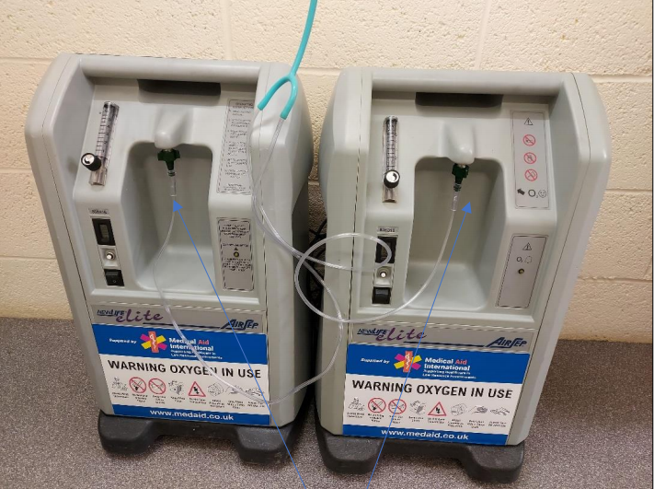The oxygen concentrator can be connected together to increase output

* 300 x [5 litres concentrators](https://www.medaid.co.uk/refurbished-oxygen-concentrators/) (plus accessories including adult and paediatric masks and nasal cannula)
* 150 x [Lifebox pulse oximeters](https://www.lifebox.org/what-we-do/pulse-oximetry/" \l "3" \t "_blank) (plus accessories)
* 15 x [emergency bags](https://www.medaid.co.uk/emergency-bag-contents/)
* 15 x [biomedical engineering training courses](https://www.medaidacademy.co.uk/biomedical-engineering/)
* 30 x generators.

Alongside equipment and MAI’s renowned biomedical engineering training course, recipient hospitals will also receive on-going maintenance support.

**The cost of this life saving equipment is £100,000.**

Treating up to 300 patients at a time and with machine lifespans of 4-5 years or many more, these concentrators and their associated support package, will improve health outcomes for tens of thousands of people.

WFSA will match every £ or $ raised

WFSA are looking to match donations up to a maximum of £50,000 bringing the total appeal to £100,000.

Why Oxygen matters

**Oxygen is essential:**Oxygen saves lives. It is included on the WHO Model Lists of Essential Medicine. Oxygen is vital for a wide range of healthcare interventions including anaesthesia,  perioperative care, and critical care.

**The oxygen crisis:** Nearly half of all hospitals in low and middle income countries, have inconsistent or no supply of oxygen.

Every year in LMICs, hundreds of thousands die from hypoxemia – or a low level of oxygen in the blood – because oxygen therapy is not available.

*“In one hospital in Africa, a colleague of mine couldn’t sleep for days when a professor died, because there was no regular supply of oxygen; no one is exempt. Oxygen saves lives. Please give generously so we can get it to where it is most needed.”*

DR BISOLA ONAJIN-OBEMBE, CONSULTANT ANAESTHESIOLOGIST, NIGERIA.

**Health implications:** Hypoxemia affects millions of people each year suffering from a range of common conditions – including, pneumonia, new born conditions, and obstetric emergencies. When severe hypoxemia is not quickly diagnosed and addressed, it can lead to death.

* Global estimates suggest that one in five sick new borns has hypoxemia upon admission to a hospital.
* 15% of pregnant women in LMICs develop life-threatening complications, many of whom could be treated with oxygen therapy.
* Pneumonia is the leading cause of death in children under 5 years of age.

Other conditions for which oxygen is a vital and critical therapy include: chronic obstructive pulmonary disease (COPD); pneumonia; asthma; bronchopulmonary dysplasia; underdeveloped lungs in newborns; heart failure; cystic fibrosis; sleep apnea; lung disease; and trauma to the respiratory system. The aim of supplemental oxygen therapy in patients with COVID-19 disease is to support adequate oxygenation for physiological processes while avoiding hypoxemia.

**Impact of oxygen therapy**: Oxygen is essential for anaesthesia care, perioperative care, and critical care. The World Health Organization (WHO) and has included in its Model List of Essential Medicines under general anaesthetics for nearly 40 years.

* Administering oxygen therapy, antibiotics, and other supportive care practices for severe neonatal infections could save the lives of more than 400,000 babies each year.
* There is a 35% possible reduction in risk of death from childhood pneumonia with the introduction of improved oxygen delivery systems.
* Pulse oximeters and oxygen therapies can decrease patient deaths by one third.

**Oxygen therapy systems:** A key tool combating this lack of oxygen is the oxygen concentrator. Oxygen concentrators draw in air from the environment to provide a reliable, inexpensive, and continuous source of oxygen for multiple patients at the same time.

[MAI (Medical Aid International)](https://www.medaid.co.uk/)  is an internationally renowned social enterprise providing low cost high quality refurbished oxygen concentrators to this appeal as part of a complete oxygen therapy package. Refurbished concentrators cost around 6 times less than new to market models.  They provide an extremely cost effective solution to the realities faced in many LMIC hospitals, and even more so when combined with the free accessories, [emergency bags](https://www.medaid.co.uk/emergency-bag-contents/) and [biomedical engineering courses](https://www.medaidacademy.co.uk/biomedical-engineering/) being generously donated by MAI as part of this partnership.

**Get involved**

Share this appeal with your departments, colleagues, friends and families through social media, emails, posters and presentations. We’ll double every pound or dollar you raise.

<https://wfsahq.org/get-involved/donate/uniting-for-oxygen-appeal/>